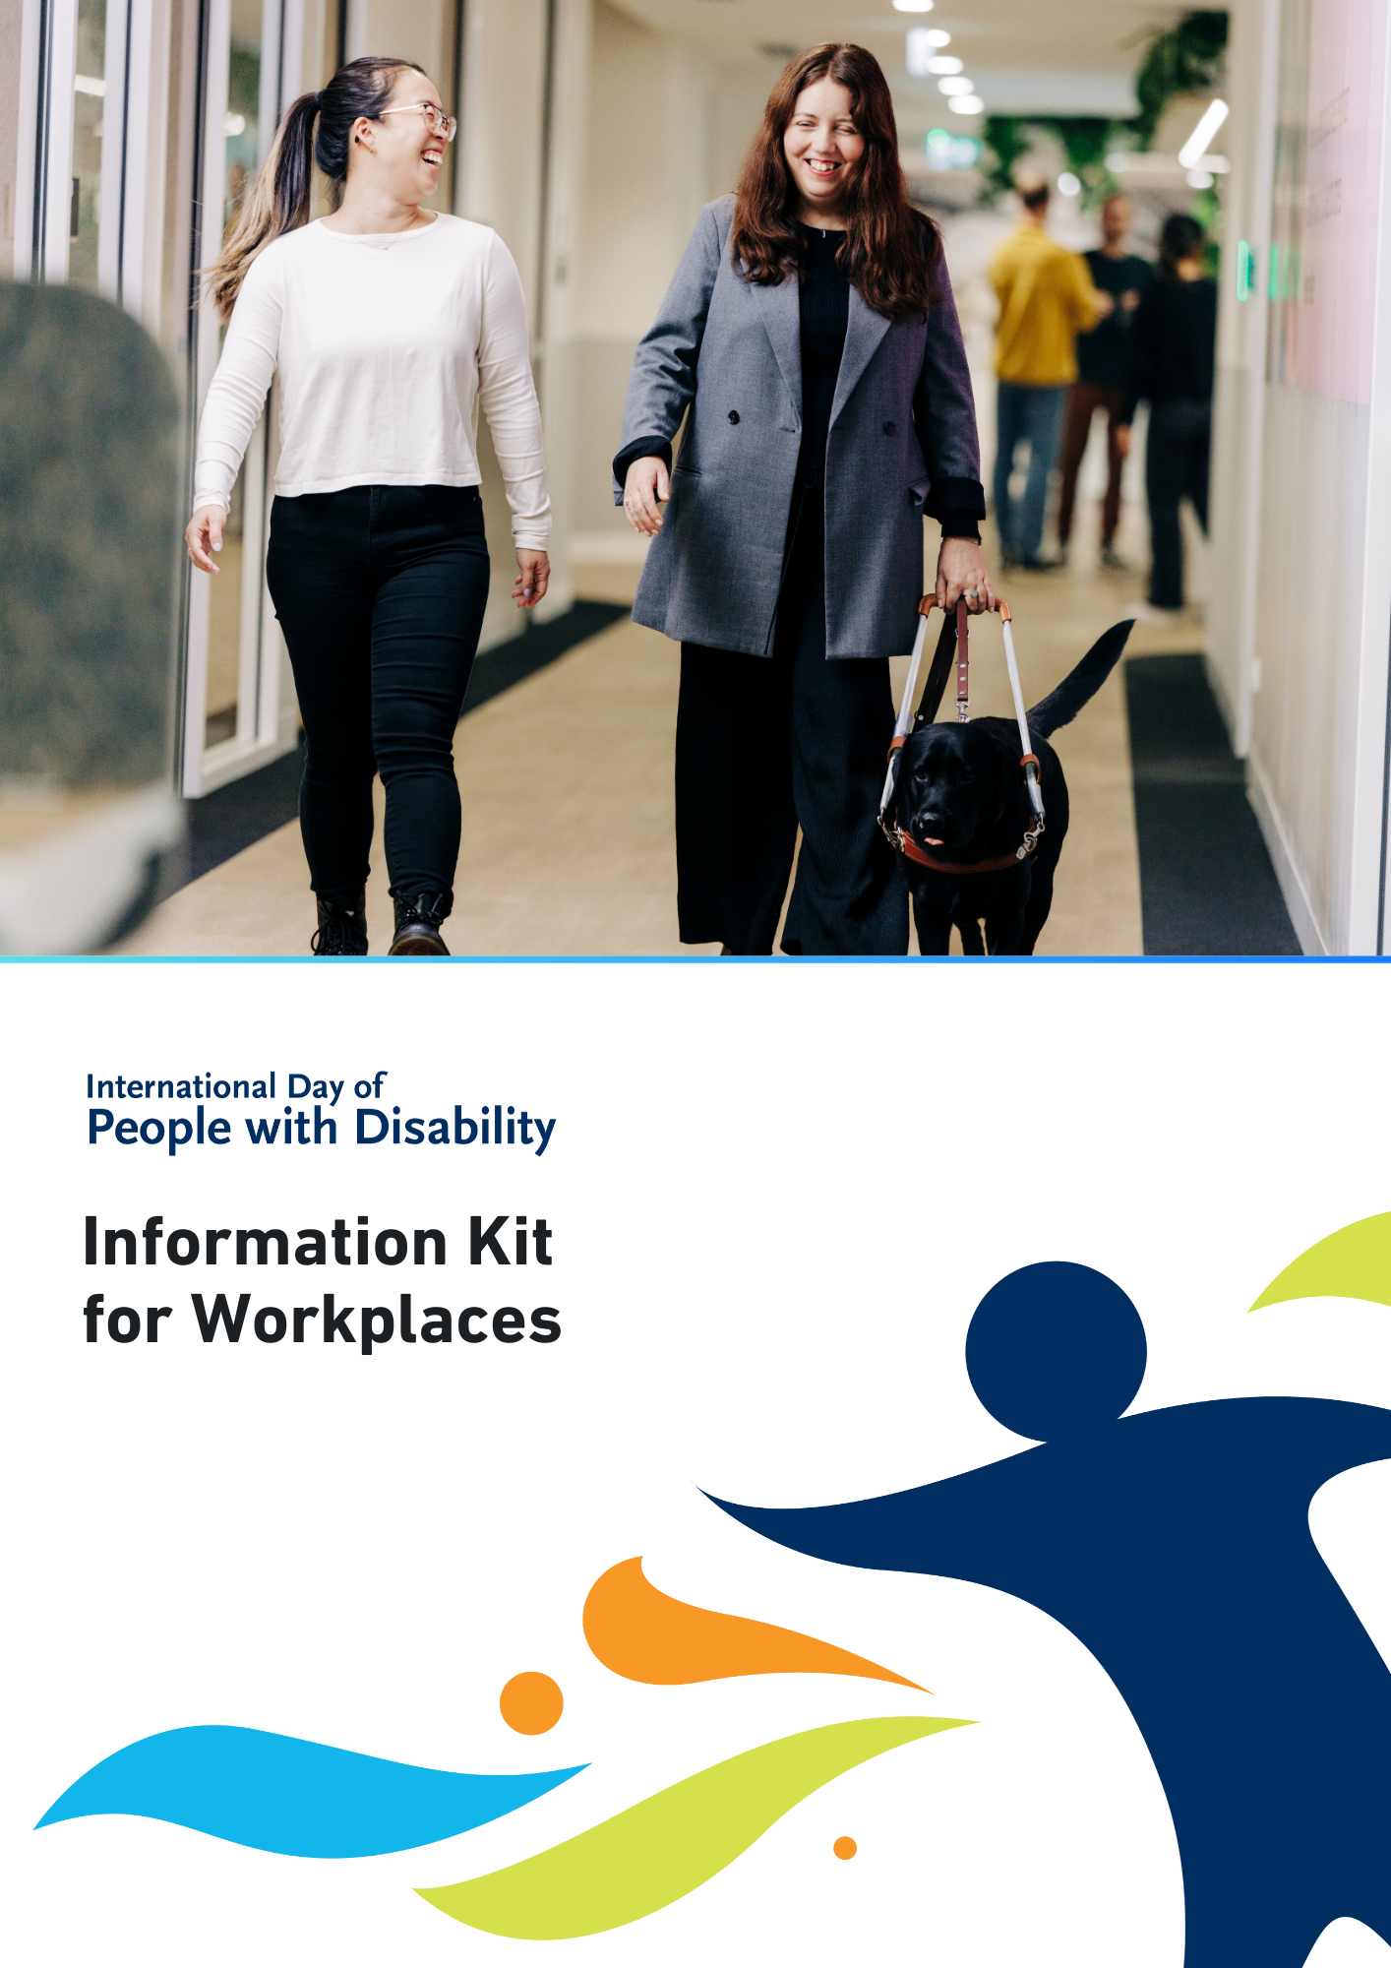

International Day of People with Disability (IDPwD) is a United Nations day, observed internationally each year on 3 December. In Australia, it is a day to promote awareness, understanding and acceptance of the 5.5 million people with disability in the country.

A key part of IDPwD each year are the events and activities that schools, workplaces and community groups hold to mark the day.

Workplaces play a vital role in creating a more inclusive and diverse community in Australia. This information kit has been developed to help workplaces get involved.

# **Did you know?[1]**

* There are 5.5 million people with disability in Australia – that’s 1 in 5 people
* 15% of people in Australia aged 0-64 years have disability
* 52% of people in Australia aged 65 years and over have disability
* 7.9% of all Australians have a profound or severe disability
* 9.9% or 1 in 10 people with disability in Australia have experienced discrimination.

For more information about disability statistics in Australia, please visit the [Australian Bureau of Statistics website](http://www.abs.gov.au/statistics/health/disability/disability-ageing-and-carers-australia-summary-findings/2022).

# **IDPwD theme**

Each year, the [United Nations](https://www.un.org/en/observances/day-of-persons-with-disabilities) announces a theme for IDPwD. The theme assists in breaking down barriers and promoting diversity and inclusion.

The theme for IDPwD 2024 is:

**Amplifying the leadership of persons with disabilities for an inclusive and sustainable future.**

You can read an Easy Read version and learn more about the theme on the [About IDPwD](https://www.idpwd.com.au/about/about-idpwd/) webpage.

You may wish to incorporate the official theme into your own activities or event, or develop your own theme that best relates to you. There are some links on our [Inclusion resources](https://www.idpwd.com.au/resources/inclusionresources/) webpage to help get you started.

# **Ways your workplace can get involved**

There are many ways your workplace can recognise IDPwD on 3 December and all year round. Regardless of how big or small your involvement is, we encourage you to get creative and mark IDPwD in your own unique way.

## Host your own IDPwD event or activity

Holding events or activities are a great way to observe IDPwD and start inclusive conversations at work.

We encourage you to register your workplace event, so we know about all the events happening across Australia. You have the option to keep your event private or register as a public event and be featured on our community event calendar. To find out more, visit the [Event Registrations page](http://www.idpwd.com.au/events/event-registrations) on the IDPwD website.

Here are some ideas to get you started.

## Learn about disability inclusion together

* Inclusive workplaces benefit from the diversity of perspectives and experiences.
* Our [Inclusion Resources page](https://www.idpwd.com.au/resources/inclusionresources/) has useful links like an inclusive language toolkit for recruitment, and ways to host accessible events and meetings.
* You can also encourage your managers and team members to take part in disability awareness training.

## Film screening

* Host a screening of short films or videos that feature people with disability or disability themes.
* Check out our [IDPwD Ambassador videos](https://www.idpwd.com.au/about/our-ambassadors/) to learn about this year’s Ambassadors and their stories.
* Visit the [Focus on Ability Short Film Festival website](https://focusonability.com.au) to explore a diverse selection of short films. If you’d like to showcase their films at your event, you can send a request to [admin@focusonability.com](mailto:admin@focusonability.com)

## Morning or afternoon tea

* Host a morning or afternoon tea with your workplace to recognise IDPwD.
* Consider inviting a person with disability or disability advocate from your local community to speak about their experiences.

## Volunteering

* If your workplace offers volunteer leave, consider volunteering with a local organisation that provides services and supports for people with disability.

## Workplace awards

* Acknowledge the people in your workplace who are championing disability inclusion.
* This could include recognising the accomplishments of staff members or teams who are leading the way in adopting inclusive practices at work.
* You can use the [editable IDPwD Certificate](https://www.idpwd.com.au/resources/award-certificate-certificate-of-appreciation) or create your own template and include elements of the [IDPwD logo and branding.](https://www.idpwd.com.au/resources/logo/)

# **Join the conversation**

If you can’t hold or attend an event, you can still get involved in IDPwD and help raise awareness. Here are some ideas:

* Get your colleagues together and support other IDPwD events in your local community or online. Check out our [community event calendar](http://www.idpwd.com.au/events/calendar) for events happening near you.
* Learn more about IDPwD by [checking out our fact sheets](https://www.idpwd.com.au/resources/fact-sheets/), which are available in 12-langauges other than English, Auslan and Easy Read.
* Promote IDPwD in your online meetings and emails using customisable resources like the IDPwD [PowerPoint presentation](https://www.idpwd.com.au/resources/powerpoint-presentation-template), [virtual meeting backgrounds](https://www.idpwd.com.au/resources/virtual-meeting-backgrounds)and [signature blocks](https://www.idpwd.com.au/resources/email-signatures).
* Follow or tag IDPwD on [Facebook (@idpwd)](https://www.facebook.com/idpwd) and [Instagram (@idpwd_au)](https://www.instagram.com/idpwd_au/) to help spread stories about people with disability and be part of the community all year round.
* Publish an article or acknowledgement in your workplace newsletter about IDPwD (see template below).

**International Day of People with Disability with [organisation name]**

International Day of People with Disability (IDPwD) is a United Nations day observed on 3 December each year to increase public awareness, understanding and acceptance of people with disability.

There are 5.5 million people with disability in Australia – that’s one in five people. By acknowledging this important day, we can take action and contribute to positive change at work and beyond.

Workplaces play a key role in ensuring people with disability can participate in all aspects of community life.

This year [organisation] will mark IDPwD by [insert details of your event or activity].

We encourage everyone to get involved this IDPwD. Together we can challenge perceptions about disability, remove barriers, and promote inclusive and respectful attitudes and behaviours in our community.

For more information, go to [your website address] or contact [your phone number/email address]. You can also visit our [your Facebook page] for updates.

For more information about IDPwD, visit [www.idpwd.com.au](http://www.idpwd.com.au)

**More information**

Visit[idpwd.com.au](http://www.idpwd.com.au) to find out more and access stories, videos and resources.

If you have any questions, you can:

* email us at [idpwd@dss.gov.au](mailto:idpwd@dss.gov.au)
* call us on 1800 440 385, 9am to 5pm Monday to Friday AEST/AEDT.

TTY (Speak and Read) users can phone 1800 555 677 and ask to be connected to IDPwD at 1800 440 385.

1. Source: Disability, Ageing and Carers, Australia survey 2022, Australian Bureau of Statistics [www.abs.gov.au/disability](http://www.abs.gov.au/disability)