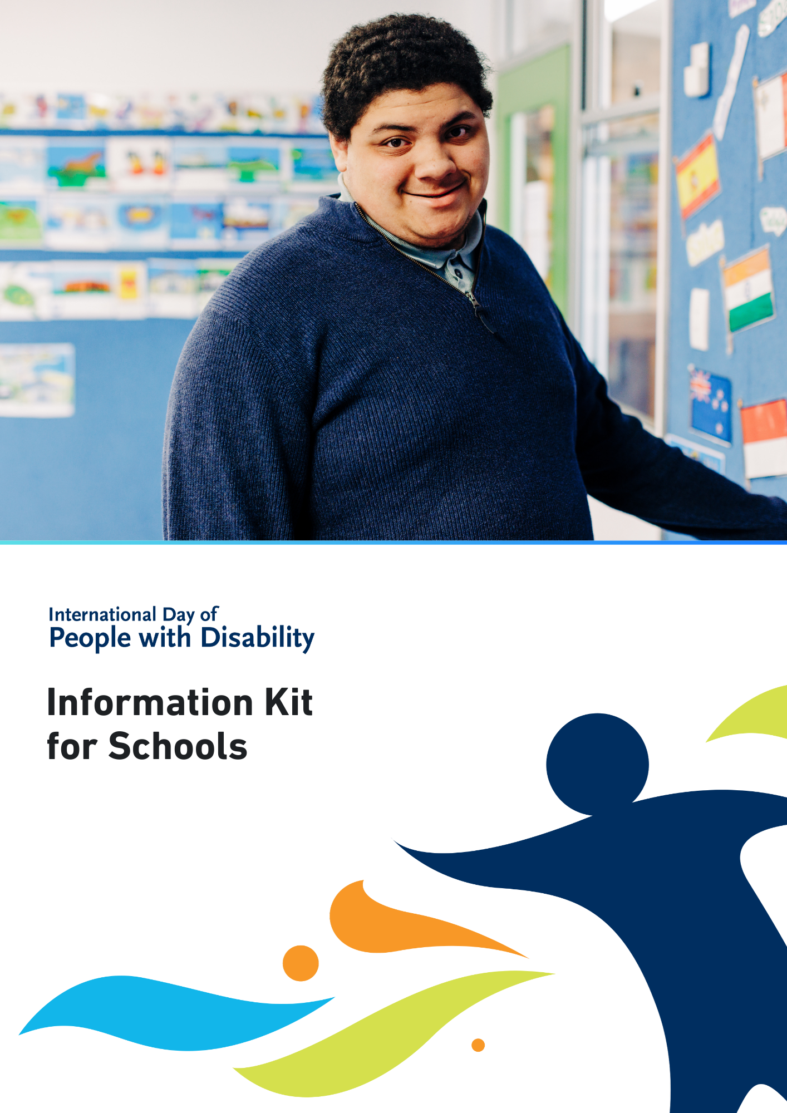

International Day of People with Disability (IDPwD) is a United Nations day, observed internationally each year on 3 December. In Australia, it is a day to promote awareness, understanding and acceptance of the 5.5 million people with disability in the country.

A key part of IDPwD each year are the events and activities that schools, workplaces and community groups hold to mark the day.

Schools play an important role in creating a more inclusive and diverse community in Australia. This information kit has been developed to help schools get involved.

# Did you know?[1]

* There are 5.5 million people with disability in Australia – that’s 1 in 5 people
* 15% of people in Australia aged 0-64 years have disability
* 52% of people in Australia aged 65 years and over have disability
* 7.9% of all Australians have a profound or severe disability
* 9.9% or 1 in 10 people with disability in Australia have experienced discrimination.

For more information about disability statistics in Australia, please visit the [Australian Bureau of Statistics website](http://www.abs.gov.au/statistics/health/disability/disability-ageing-and-carers-australia-summary-findings/2022).

# IDPwD theme

Each year, the [United Nations](https://www.un.org/en/observances/day-of-persons-with-disabilities) announces a theme for IDPwD. The theme assists in breaking down barriers and promoting diversity and inclusion.

The theme for IDPwD 2024 is:

**Amplifying the leadership of persons with disabilities for an inclusive and sustainable future.**

You can read an Easy Read version and learn more about the theme on the [About IDPwD](https://www.idpwd.com.au/about/about-idpwd/) webpage.

You may wish to incorporate the official theme into your own activities or event, or develop your own theme that best relates to you. There are some links on our [Inclusion resources](https://www.idpwd.com.au/resources/inclusionresources/) webpage to help get you started.

# Navy blue banner with idpwd.com.au and Facebook, Twitter and Instagram symbolsWays your school can get involved

There are many ways your school can recognise IDPwD on 3 December and all year round. Regardless of how big or small your involvement is, we encourage you to get creative and acknowledge IDPwD in your own unique way.

All resources listed below are available on the [IDPwD schools webpage](http://www.idpwd.com.au/get-involved/schools).

## IDPwD in the classroom

We have developed a range of resources for educators to incorporate disability themes and issues in the classroom:

* [**Inclusion resources**](https://www.idpwd.com.au/resources/inclusionresources/)– online resources to help educators apply inclusive practices in the classroom.
* [**Classroom resources**](https://www.idpwd.com.au/get-involved/schools/teachers/) – lesson ideas and activity sheets designed to start important conversations about disability and inclusion.
* [**Printable assets**](https://www.idpwd.com.au/resources/promotional-assets/) – interactive activities for students like a colouring-in poster, a chatterbox and make-your-own paperchain.
* [**Stories of lived experience with disability**](https://www.idpwd.com.au/stories-2/)– encourage students to read or watch stories from our Ambassadors and people with disability in the community.

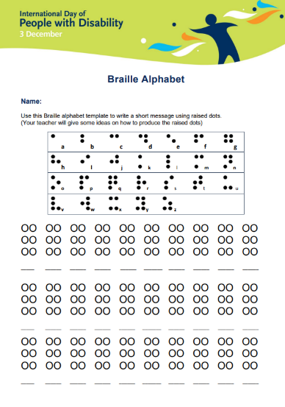

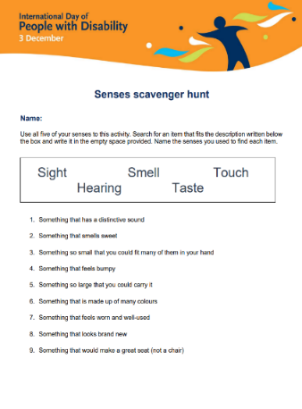

## Host your own IDPwD event or activity

Holding events or activities is a great way to observe IDPwD and start inclusive conversations at school.

We encourage you to register your school’s event, so we know about all of the events happening across Australia. You have the option to keep your event private or register as a public event and be featured on our community event calendar. To find out more, visit the [Event Registrations page](http://www.idpwd.com.au/events/event-registrations) on the IDPwD website.

Here are some event ideas to get you started.

### Creative competition

* Get students to submit artwork about what a diverse community looks like to them.
* Students could also write a short article or essay about a person with disability in the community.

### Film Screening

* Host a screening of short films or videos that feature people with disability or disability themes.
* Check out our [IDPwD Ambassador videos](https://www.idpwd.com.au/about/our-ambassadors/) to learn about this year’s Ambassadors and their stories.
* Visit the [Focus on Ability Short Film Festival website](https://focusonability.com.au) to explore a diverse selection of short films. If you’d like to showcase their films at your event, you can send a request to [admin@focusonability.com](mailto:admin@focusonability.com)

### Decorate your school

* Put up posters and decorations for IDPwD around the school or classroom.
* You can create your own IDPwD designs or use the [printable resources](https://www.idpwd.com.au/resources/promotional-assets/) on the IDPwD website.

### School assembly

* Organise a themed assembly for IDPwD and invite a guest speaker with disability from your community.
* You can also feature some of the [IDPwD Ambassador videos](http://www.idpwd.com.au/about/our-ambassadors)

### School awards

* Acknowledge students, teachers and staff who are doing their part to create a more inclusive school environment.
* You can use the [editable IDPwD Certificate](https://www.idpwd.com.au/resources/school-award-certificate-of-appreciation) or create your own template with your school’s logo and colours.

If you can’t hold an event or activity at your school, you can support other IDPwD events in your local community or online. Check out our [community event calendar](http://www.idpwd.com.au/events/calendar) for events happening near your school.

# Join the conversation

If you can’t hold or attend an event, you can still get involved in IDPwD and help raise awareness in your school community. Some ideas are:

* Post messages on your school’s website or social media about IDPwD. Check out our [online promotion kit](http://www.idpwd.com.au/resources/social-media) for ideas to get you started.
* Learn more about IDPwD by [checking out our fact sheets](https://www.idpwd.com.au/resources/fact-sheets/), which are available in 12-langauges other than English, Auslan and Easy Read.
* Promote IDPwD in your online meetings and emails using our [virtual meeting backgrounds](https://www.idpwd.com.au/resources/virtual-meeting-backgrounds)and [signature blocks](https://www.idpwd.com.au/resources/email-signatures).
* Follow or tag IDPwD on [Facebook (@idpwd)](https://www.facebook.com/idpwd) and [Instagram (@idpwd_au)](https://www.instagram.com/idpwd_au/) to help spread stories about people with disability and be part of the community all year round.
* Publish an article or acknowledgement in your school newsletter about IDPwD (see template below).

**International Day of People with Disability with [School]**

Did you know that there are over 5.5 million people with disability in Australia?

International Day of People with Disability is a United Nations day observed on 3 December each year to increase public awareness, understanding and acceptance of people with disability.

By acknowledging this important day, we can take action to remove barriers people with disability in Australia and contribute to positive change in our classrooms and our community.

This year [school] is recognising IDPwD by [insert details of your event or activity].

We encourage all students, their families and carers to get involved this IDPwD. Together, we can all take action to challenge perceptions about disability, remove barriers, and promote inclusive and respectful attitudes and behaviours in our community.

For more information, go to [your website address] or contact [your phone number/email address]. You can also visit our [Facebook page] for updates.

For more information about IDPwD, visit [idpwd.com.au](http://www.idpwd.com.au)

# More information

Visit[idpwd.com.au](http://www.idpwd.com.au) to find out more and access stories, videos and resources.

If you have any questions, you can:

* email us at [idpwd@dss.gov.au](mailto:idpwd@dss.gov.au)
* call us on 1800 440 385, 9am to 5pm Monday to Friday AEST/AEDT.

TTY (Speak and Read) users can phone 1800 555 677 and ask to be connected to IDPwD at 1800 440

1. Source: Disability, Ageing and Carers, Australia survey 2022, Australian Bureau of Statistics [www.abs.gov.au/disability](http://www.abs.gov.au/disability)