International Day of People with Disability

2023

Social Media Kit

International Day of People with Disability
International Day of People with Disability (IDPwD) is a United Nations (UN) observed day recognised on 3 December each year.
It is a day to promote community awareness, understanding and acceptance of people with disability—to be part of creating an inclusive and diverse community in Australia.
According to the Australian Bureau of Statistics, one in six people, or 4.4 million Australians, have disability. Not all disability is the same, and some disabilities are invisible. By joining the conversation and listening to the stories of people with disability, we can challenge our own perceptions and help make positive changes in the community.
Learn more at www.idpwd.com.au

Be part of creating an inclusive and diverse community
Social media is a great way to raise awareness of IDPwD and promote messages of disability inclusion.
We have developed this Social Media Kit to help you and your community, business or school promote your IDPwD events and activities.
It includes a few social media tiles and suggested copy to help you spread the word about IDPwD online. We have also included links to additional assets such as virtual backgrounds, social media cover photos and email signature banners that you are free to download.
If you have any questions, please email us at idpwd@dss.gov.au or call 1800 440 385 Monday – Friday (TTY users, phone 1800 555 677 and ask for 1800 440 385).

IDPwD Theme
Each year, the UN announces a theme for IDPwD. The theme gives a focus for society to remove barriers for people with disability become more inclusive.
The official UN theme for IDPwD 2023 will likely be announced in October or November. We will update the IDPwD website and social media channels when the theme is available.

Key messages
You are welcome to use and adapt the following key messages when promoting IDPwD.
- International Day of People with Disability is a United Nations observed day held on 3 December each year to increase public awareness, understanding and acceptance of people with disability.
- IDPwD is a chance to be part of creating an inclusive and diverse community in Australia.
- IDPwD is an opportunity to make positive changes to the lives of 4.4 million Australians with disability.
- Hold or attend an event in your workplace, school or community on or around 3 December to recognise the contributions and achievements of people with disability.
- Join the conversation about disability online or in your community to challenge perceptions, break down barriers and encourage a more diverse and inclusive community in Australia.
- We all have a role to play in ensuring people with disability have the opportunity to reach their full potential and participate in all aspects of community life.
- Get involved in IDPwD 2023 at www.idpwd.com.au
- Let’s all take action this December, and all year round, to be part of creating an inclusive and diverse community in Australia.

Social media posts

We have developed some suggested posts below for you to share or adapt to suit your audience.
We would also love to see all your IDPwD events and activities, so please feel free to tag us on the following social media channels:

Facebook @idpwd
https://www.facebook.com/idpwd

Twitter @idpwd
https://twitter.com/idpwd

Instagram @idpwd_au
https://www.instagram.com/idpwd_au/

Hashtags
We encourage you to use #IDPwD and #IDPwD2023 when promoting your IDPwD events and activities on social media.

Images
All images featured in this Social Media Kit can be downloaded for free at www.idpwd.com.au/resources/social-media.
We encourage you to include alt text for all images you post on social media so that your content is accessible for people with disability, particularly people who are blind or have low vision.

IDPwD social media posts
You can use the following posts to increase awareness and understanding of IDPwD
on 3 December and all year round.
If you are planning your own event or activity for IDPwD, you can check out our event information kits for inspiration and ideas. Learn more at www.idpwd.com.au/events/event-planning-kits

Post | Graphic | Alt Text
International Day of People with Disability is held on 3 December each year.  It is a day to raise community awareness, understanding, and acceptance of the 4.4 million people with disability in Australia.  Be part of creating an inclusive and diverse community.  Learn more at www.idpwd.com.au  #IDPwD #IDPwD2023 | 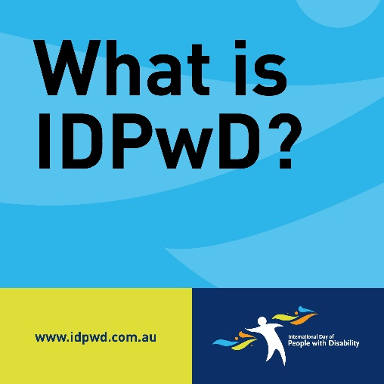 | Text reads ‘What is IDPwD?’  In the bottom left corner is the www.idpwd.com.au URL.  In the bottom right corner is the International Day of People with Disability logo.
To me, International Day of People with Disability means [add details about what IDPwD means to you]  Join me in the conversation to break down barriers and encourage a more diverse and inclusive community in Australia.  Learn more at www.idpwd.com.au  #IDPwD #IDPwD2023 | 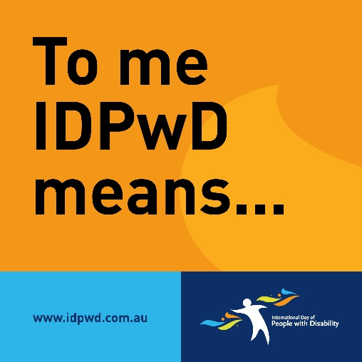 | Text reads ‘To me IDPwD means…’  In the bottom left corner is the www.idpwd.com.au URL.  In the bottom right corner is the International Day of People with Disability logo.
Today is International Day of People with Disability.  I am supporting #IDPwD2023 and taking action to be more inclusive by [add details about how you are taking part].  Learn more at www.idpwd.com.au  #IDPwD #IDPwD2023 | 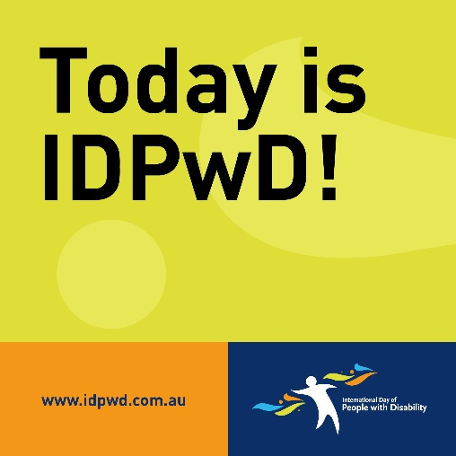 | Text reads ‘Today is IDPwD!’  In the bottom left corner is the www.idpwd.com.au URL.  In the bottom right corner is the International Day of People with Disability logo.

Other assets

We have developed a number of other assets that you can use to promote IDPwD and spread messages of disability inclusion.

For social media - www.idpwd.com.au/resources/social-media.

- Facebook and Instagram stories
- Banners for Facebook, Twitter (X) and LinkedIn

Digital and printable assets - https://www.idpwd.com.au/resources/promotional-assets/
- Virtual meeting backgrounds
- Email signature banner
- Pull up banner
- Paperchain
- Chatterbox

Creating your own promotional assets
You can use the IDPwD logo to create your own promotional materials.
The IDPwD Logo Guidelines covers how you can use our logo and colour palette, and some frequently asked questions.

Learn more at www.idpwd.com.au/resources/logo

Disability, Ageing and Carers, Australia: Summary of Findings, 2018 | Australian Bureau of Statistics (abs.gov.au)

