Celebrating
International Day of People with Disability

Social Media
Kit

International Day of People with Disability
International Day of People with Disability (IDPwD) is a United Nations (UN) observed day celebrated on 3 December each year. It is a day to acknowledge the contributions and achievements of people with disability and promote awareness, understanding and acceptance in our community.
This 2021 UN theme is ‘Leadership and Participation of persons with disabilities toward an inclusive, accessible and sustainable post-COVID-19 world.’
Almost one in five people, or 4.4 million Australians, have a disability. IDPwD is an opportunity for us have a conversation about the issues and experiences of people with disability to challenge misconceptions and break down barriers in our society.
By raising awareness in your community and sharing your story, you can help positively influence community attitudes and promote equality, inclusion and participation of people with disability.
Social media is a great tool to spread the word about IDPwD in your community. We have provided a few suggested posts to get you started. Make sure you follow and tag @idpwd on Facebook and Twitter, and @idpwd_au on Instagram and use the hashtag #IDPwD.
Digital resources, including social tiles, videos and case studies are also available on the website www.idpwd.com.au

Key messages
- International Day of People with Disability is a United Nations observed day celebrated on 3 December each year to increase public awareness, understanding and acceptance of people with disability.
- It is an opportunity for our community to make positive changes to the lives of 4.4 million Australians with disability.
- Hold or attend an event on 3 December to celebrate the contributions and achievements of all Australians with disability.
- You can also join the conversation in your community to challenge stereotypes, break down barriers and encourage inclusive attitudes and behaviours.
- We all have a role to play in ensuring people with disability have the opportunity to reach their full potential and participate in all aspects of community life.
- Let’s all take action this December, and all year round, to make our society more inclusive.
- Even the smallest action can have a big impact for people with disability.
- Share your celebration or show your support on social media by tagging #IDPwD
- To find out more, go to www.idpwd.com.au

Help spread the word online

Social media content
We have included some suggested posts below for you to share or customise with your own personal message.

Facebook, Instagram or LinkedIn
Type | Suggested content
IDPwD reminder | International Day of People with Disability is almost here!  We can’t wait to celebrate the contributions and achievements of people with disability on 3 December.  Find out more at www.idpwd.com.au [or add web link] #IDPwD
Customised post on IDPwD | Today we celebrate International Day of People with Disability because [add statement about what IDPwD means to you or your school/workplace/community group].  Let’s all take action to make our community more inclusive and accessible for people with disability #IDPwD
Generic post on IDPwD | Today we celebrate International Day of People with Disability and acknowledge the 4.4 million Australians with disability.  Join the conversation this #IDPwD to help raise awareness, challenge stereotypes and break down barriers.  Together we can make our community more accessible and inclusive for people with disability so that everyone has the opportunity to participate.
Generic post on IDPwD with  UN theme | Today we celebrate International Day of People with Disability.  This year’s theme is ‘Leadership and Participation of persons with disabilities toward an inclusive, accessible and sustainable post-COVID-19 world.’  Let’s all work together to remove barriers for the 4.4 million Australians with disability so that everyone can participate and feel included in our community #IDPwD
Post IDPwD | Look at how we celebrated International Day of People with Disability!  We [add details of event/how you celebrated].  Let’s continue the conversation all year round to remove barriers in our society and help make Australia more inclusive for people with disability. [add event photographs] #IDPwD

Twitter
Type | Suggested content
Generic post on IDPwD | Today we celebrate @idpwd!  Let’s all work together to make our community more inclusive and accessible for the 4.4 million Australians with disability #IDPwD

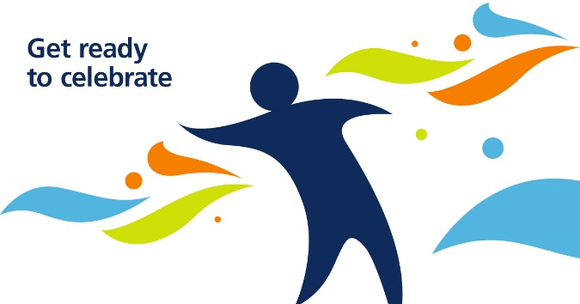
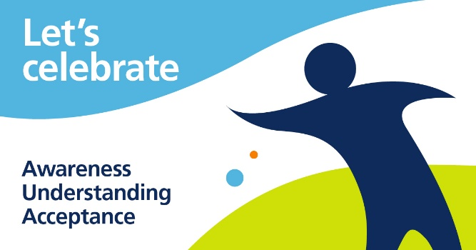
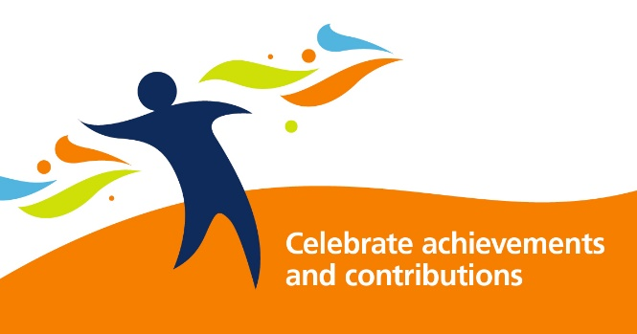
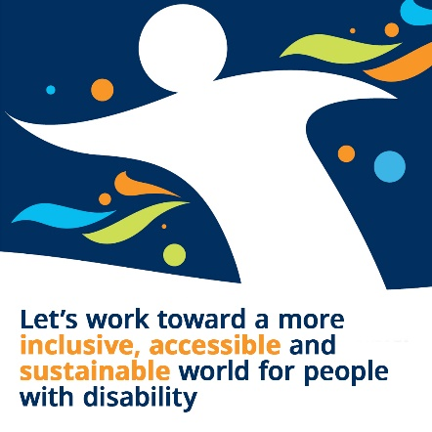
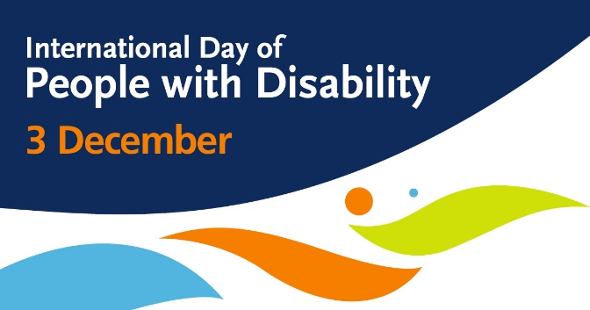
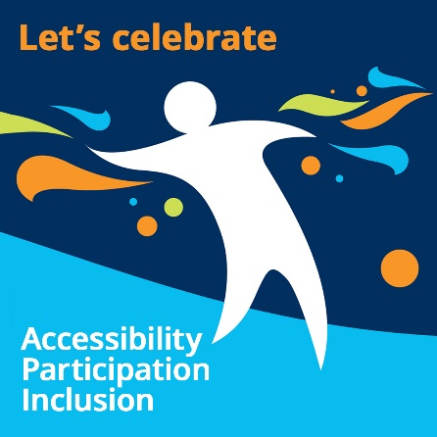
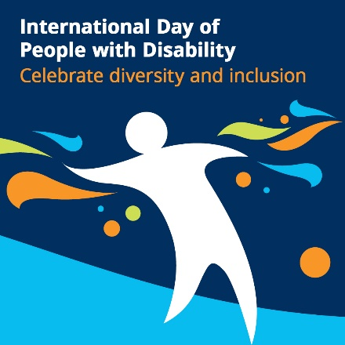
Sample social media tiles

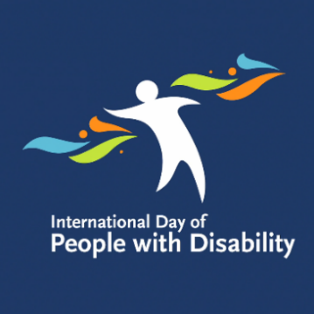
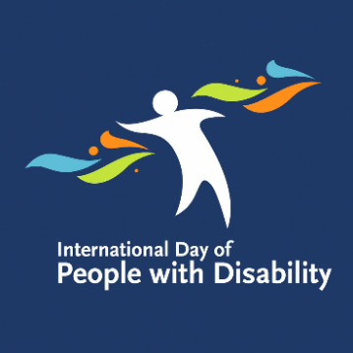
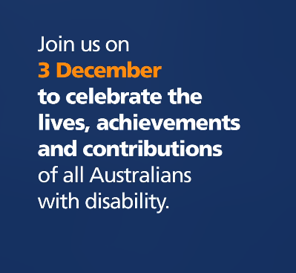
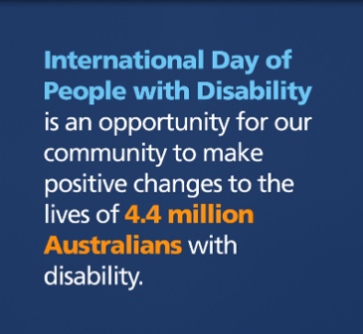
Animated tiles

Social media tiles are available for you to download on the website www.idpwd.com.au.

Follow and tag us!

Make sure you follow and tag us in your #IDPwD posts!
Facebook: @idpwd
https://www.facebook.com/idpwd
Twitter: @idpwd
https://twitter.com/idpwd

Instagram: @idpwd_au
https://www.instagram.com/idpwd_au/

Hashtags: #IDPwD or #IDPwD2021

More information
Go to www.idpwd.com.au to find out more and access the latest news, stories and resources. You can also subscribe to receive updates.
Follow @idpwd on Facebook and Twitter and @idpwd_au on Instagram and use the hashtag #IDPwD to join the conversation online.
You can also email us at idpwd@dss.gov.au or call 1800 440 385 (TTY users, phone 1800 555 677 and ask for 1800 440 385).

