Celebrating
International Day of People with Disability

Information kit for workplaces

Contents
What is International Day of People with Disability? 3
How workplaces can get involved 3
Hold or attend an event 4
Event ideas 4
Event tips 5
Make your event accessible 7
Event planning checklist 9
Join the conversation 10
Key messages 10
Social media posts 11
Social media tiles 12
Newsletter article or intranet content 13
More information 13

What is International Day of People with Disability?
Every year on 3 December, people around the world take part in International Day of People with Disability (IDPwD). It is a day to celebrate the contributions and achievements of people with disability and promote awareness, understanding and acceptance in the community.
A key part of IDPwD are the events that schools, workplaces and community groups hold to mark the day. Every event helps to make positive changes to the lives of 4.4 million Australians with disability.
There are also many other ways you can get involved, including joining the conversation online or in your community about the issues and experiences of people with disability to challenge misconceptions and break down barriers.
Let’s all take action this December, and all year round, to help make Australia more inclusive for people with disability.

How workplaces can get involved
We encourage all workplaces to join the celebration for International Day of People with Disability. There are many ways you can get involved:
- Hold or attend an event on, or around, 3 December to celebrate.
- Join or start a conversation in your community to promote awareness, understanding and acceptance of people with disability.
- Read, watch and listen to the stories and experiences of people with disability to challenge your attitudes and assumptions.
- Take action in your workplace to remove barriers and improve accessibility for people with disability.
- Help spread the word and share your messages of support online.
This information kit includes ideas and tips to help get you started, but we also encourage you find your own unique way to acknowledge and celebrate people with disability in your workplace.

Hold or attend an event
Events are a great way to celebrate the contributions and achievements of people with disability in your workplace or community. Whether your event is big, small, in-person or online, you’ll be helping us to break down barriers and ensure everyone feels valued and included.
It’s important to register your event on the IDPwD website www.idpwd.com.au so we know about all of the events happening across Australia for IDPwD. You have the option to keep your event private or have it listed on our community event calendar to encourage people to attend and support your event.
When you register, you can also choose to receive complimentary IDPwD lapel pins for your staff and guests. The pin design was taken from a bright and beautiful artwork by Oliver Mills, a South Australian artist and poet with cerebral palsy, epilepsy and vision impairment.
This information kit includes ideas and tips to help you plan, theme and deliver your event, including things to consider in making your event accessible for people with disability.
There are also digital and printable resources available on the IDPwD website.
If you are holding an in-person event or gathering for IDPwD, please adhere to your state or territory government’s restrictions and advice in regards to COVID-19. Visit the Department of Health website for more information or the Disability Gateway for disability information and support.

Event ideas
Looking for ways you can celebrate? This list will help you get started.
Activity | Description
Awards | - Acknowledge the achievements of staff members championing inclusive and accessible practices in the workplace.  - Your workplace could also sponsor community awards to recognise the contributions of people with disability in your local community.
Awareness in action | - Put up posters and decorations in your workplace and take a group photo to post on social media or on your staff intranet.
Fundraising | - Help a charity organisation that provides services and supports for people with disability by volunteering or supporting a fundraising drive.  - You could also run a fundraiser at your workplace with a particular theme or activity and ask staff to donate.
Guest speaker | - Organise a guest speaker with disability to speak at your workplace and share their story.
Morning or afternoon tea | - Host a morning or afternoon in your workplace. Consider inviting a person with disability, disability advocate and/or your local member to speak.
Sporting game or activity | - Host an inclusive sporting game, activity or group fitness class with special equipment or restricted senses and movements. Examples include seated volleyball, wheelchair basketball or a modified boot camp.
Film screening | - Hold a film screening with short films or videos featuring people with disability or disability themes. Check out Focus on Ability for a great range of short films.
Webinar | - Organise a webinar on a specific topic or theme related to accessibility and inclusion in the workplace.

Event tips
Once you’ve decided what type of event you want to hold, here are a few tips to help you plan and deliver your celebration.
Set your goal
- Decide what you want to achieve from your event – what is the overall purpose of your event? How will you celebrate people with disability? How will your event contribute to promoting inclusion in the workplace?
- Consider the size of your event and who you want to attend – do you want a large event for your whole workplace or do you want individual teams or offices to host their own events? Do you want to invite special guests, speakers or family and friends?
- Make sure you consider your event budget.

Get others on board
- Decide who will organise your event – will you need to put a call out for volunteers? Consider putting together an event planning committee to brainstorm ideas and allocate tasks for your event, including organising speakers, catering and activities
- If you need to reach out to external organisations or suppliers to support your event, make sure you get them on board early.

Choose a name and theme
- Think of a catchy name for your event to get everyone excited.
- You may also like to consider an overall theme for your event. The official United Nations theme for IDPwD 2021 is ‘Leadership and participation of persons with disabilities toward an inclusive, accessible and sustainable post-COVID-19 world’.

Location, location
- Choose a suitable venue that can accommodate your expected number of guests and your requirements – do you need to hire additional staging, audio or equipment? Do you need catering? If your event is outdoors, do you have a wet weather contingency plan?
- Most importantly, make sure your venue is accessible – this includes considering requirements of people with disability who may be supporting or attending your event. See the section Make your event accessible for things to consider.
- Reach out to local disability organisations or experts if you need advice.

Invite special guests or speakers
- Consider inviting a speaker to your event, such as a local community leader, disability advocate or person with lived experience of disability.
- Reach out to special guests early to confirm their availability and any special assistance they may need (e.g. carer, interpreter or catering requirements).

Make it official
- Register your event on the IDPwD website. You have the option to keep your event private if it is a staff-only event or advertise it on our community event calendar. By registering your event, you can also choose to receive complimentary IDPwD lapel pins for your staff and guests.

Spread the word
- Send out your invitations! If you are inviting special guests or members of the public, make sure you give them plenty of notice.
- Consider how you will promote your event, this may include:
  - Email
  - Staff intranet
  - Word-of-mouth
  - Newsletters, bulletins or noticeboards
  - Promotional posters or flyers
  - Advertisement in your local newspaper or pitching your event to local media
  - Listing it on the community event calendar on the IDPwD website.
  - Website or social media - make sure you tag @idpwd on Facebook or Twitter or use the hashtag #IDPwD on all of your social media channels.

Plan your celebration
- Plan and organise all of your event logistics, including catering and equipment. Make sure you consider any additional equipment you may need to hire or source externally to for your event. Check out the Event Checklist below.
- Make sure your event is accessible for guests with disability – see Make your event accessible for some things to consider when planning your celebration.
- Think about how you will theme and decorate your event, including any printing requirements. Check out the IDPwD website for printable resources, including posters and decorations.

Celebrate!
- Now that you have done all of the hard work, make sure you take time to join in the celebration.
- We want to know about all of the events happening across Australia for IDPwD, so make sure you share your celebration online and tag us at @idpwd and use the hashtag #IDPwD

Make your event accessible
If you are planning an event for IDPwD, it’s important that you make sure it is accessible for people with disability, particularly if you have any special guests or speakers with disability attending. Here is a list of some things you should consider.
Planning
- When choosing a venue, check to make sure all areas are accessible, including entrances, aisles, staging and entertainment, catering and seating areas and toilets.
- Check to make sure there are accessible parking spaces and public transport options in close proximity to the venue.
- Make sure your venue has good lighting and ventilation.
- Hire additional equipment if needed to support your event. For example if your event has an entertainment or audio component, consider booking an AUSLAN interpreter or hiring a hearing loop system. Try to limit special effects such as strobe lighting and smoke.
- Allow sufficient time in your event program for people who may need frequent breaks or more time to move between activities.
- Provide a variety of catering options and include items that are easy to pick up and eat. Ensure special meals are clearly labelled.
- Ask your speakers and guests to let you know if they have any special requirements in advance.
- Seek advice from local disability organisations or experts if you need assistance.

Setting up
- Make sure all areas are accessible and there are no obstacles or trip hazards. This includes securing electrical cables.
- Reserve seating or areas for guests that require special assistance, including people with a hearing or vision impairment, people with wheelchairs or mobility aids, people with assistance dogs, and people with interpreters or carers. This includes reserving a separate, quiet area for guests to take a break if needed.
- Make sure you leave sufficient space between tables and equipment for wheelchairs.
- Check that all of your equipment is at an appropriate height or can be adjusted if needed.

On the day
- Make sure event signage is in place and easily visible. The print should be large enough and written in Plain English so it is easy to understand.
- Make sure all of your event staff and volunteers have been briefed on accessibility so they can assist guests, including location of toilets, designated seating areas and alternative forms of communication.
- Designate staff to meet and greet attendees and invited guests.
- Ensure that all your guests are settled and as comfortable as possible.

Communication
- Use an accessible font for event signage and materials, such as invitations, programs and nametags. Font should be plain, as large as possible (minimum 12 point size) with appropriate spacing and in contrasting colours.
- Make sure your invitations or digital promotions are accessible and provide different methods for people to register or buy tickets, including online, phone and in-person. Also, make sure people are able to let you know if they have any special requirements.
- If you are using a PowerPoint presentation, use contrasting colours (i.e. light coloured font on a dark background or dark font on a white background). Also have written copies of presentations available on the day. Presenters should also describe any visual content in the presentation.
- If you are using video, make sure all videos have captions and consider audio descriptions where appropriate.
- Consider making written information available in alternate forms such as Easy Read, large print, audio recording or Braille, as appropriate.
- Use appropriate and inclusive language when communicating with people with disability.
- Consider different methods of promoting your event to tailor to a range of disabilities. Also check any information or materials published online to make sure they are available in an accessible format, such as Word or HTML.

Event planning checklist
Plan your celebration
Choose your celebration
Book a venue
Confirm the date and time
Tell everyone involved in planning your event
Make it official
Register your event on the IDPwD website
Request official IDPwD merchandise on your registration form
Invite guests and speakers
Invite officials, community leaders, local stars and/or speakers
Design and send out your event invitations using the IDPwD logo and style guide
Organise your logistics
Finalise your event program, speakers and entertainment
Confirm catering, including special dietary requirements
Confirm set-up and equipment, including AV, staging and seating arrangements.
Confirm your final guest list and/or ticketing arrangements
Confirm parking arrangements and reserve specific parking spots or areas if needed
Confirm work health and safety, first aid and security requirements
Book a photographer or organise someone to take photos at your event
Check that your event is accessible
Make some noise
Develop promotional materials and apply the IDPwD logo
Promote your event on your website/intranet and social media using the IDPwD tiles
Theme and decorate your event
Download and print IDPwD resources for your event, including posters, banners, activity sheets, fact sheets and a selfie frame for social media
Make your event signage and materials using the IDPwD logo and style guide
Connect with us
Follow @idpwd on Facebook and Twitter
Subscribe to our mailing list on the IDPwD website
After your event
Thank everyone involved in your celebration – you can use our IDPwD certificate
Post photos from your event on social media – make sure you tag @idpwd or use #IDPwD
Share your celebration with us by completing the Share Your Story form on our website.

Join the conversation
If you can’t organise or attend an event, you can still get involved in IDPwD and help raise awareness in your workplace and in the broader community.
Almost one in five people, or 4.4 million Australians, have a disability. By joining the conversation about disability, you can challenge misconceptions, break down barriers and help make your workplace more accessible and inclusive for people with disability.
How you can help spread the word:
- Post messages of support on your social media pages, including details of how you celebrated IDPwD or what your workplace is doing to recognise people with disability and promote inclusion.
- Publish an article in your staff newsletter or on the intranet.
- Send targeted emails to your staff, customers and stakeholders to encourage them to get involved.
- Talk within your teams and networks – start a conversation at your next team meeting or morning tea.
- Support other IDPwD events in your local community or online. Check out our community event calendar for events happening near you.
- Follow @idpwd on Facebook and Twitter to be part of the community and help spread positive stories about people with disability all year round.

The smallest action can make a difference! To get you started, we have included some key messages, social posts and a newsletter article below. Digital resources are also available on the IDPwD website.

Key messages
- International Day of People with Disability is a United Nations observed day celebrated on 3 December each year to increase public awareness, understanding and acceptance of people with disability.
- It is an opportunity for our community to make positive changes to the lives of 4.4 million Australians with disability.
- Join us on 3 December to celebrate the contributions and achievements of all Australians with disability.
- You can also start or join a conversation in your community to challenge stereotypes, break down barriers and encourage inclusive attitudes and behaviours.
- We all have a role to play in ensuring people with disability have the opportunity to reach their full potential and participate in all aspects of community life.
- Let’s all take action this December, and all year round, to make our community more inclusive.
- To find out how you can get involved, go to www.idpwd.com.au

Social media posts
Social media can be a great tool to spread the word about IDPwD and promote what your workplace is doing to recognise and include people with disability. We have provided a few suggested posts to get you started. Make sure you follow and tag @idpwd on Facebook and Twitter, or use the hashtag #IDPwD.
Facebook, Instagram or LinkedIn
Timing | Suggested content
Pre-event | We’re holding an event for International Day of People with Disability!  Join us [details of the event] to recognise people with disability in our workplace and celebrate inclusion.  For more details, go to [registered event web link] #IDPwD
Generic post on IDPwD | Today we celebrate International Day of People with Disability.  Join the conversation this #IDPwD to help raise awareness, challenge stereotypes and break down barriers.  Together we can make our workplaces and communities more accessible and inclusive for people with disability.
Generic post on IDPwD –  UN theme | Today we celebrate International Day of People with Disability.  This year’s theme is ‘Leadership and Participation of persons with disabilities toward an inclusive, accessible and sustainable post-COVID-19 world.’  Let’s all work together to remove barriers for the 4.4 million Australians with disability so that everyone can participate and feel included in our community #IDPwD
Post-event | Look at how we celebrated International Day of People with Disability!  We held a [details of the event] to celebrate diversity and inclusion in our workplace. [add event photographs] #IDPwD
Twitter
Timing | Suggested content
Pre-event | Join us on [event date] for [event name] as we celebrate @idpwd and recognise people with disability in our workplace and community.  Check out [registered event web link] #IDPwD
Event day or generic post on IDPwD | Today we celebrate @idpwd.  Let’s all work together to make our workplaces and communities more accessible and inclusive for the 4.4 million Australians with disability #IDPwD
Post-event | Thank you to everyone who joined us on @idpwd to celebrate the contributions and achievements of people with disability in our community! [add event photographs] #IDPwD

Social media tiles
Social media tiles are available for you to download on the IDPwD website.
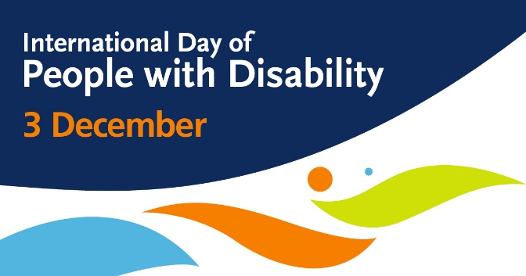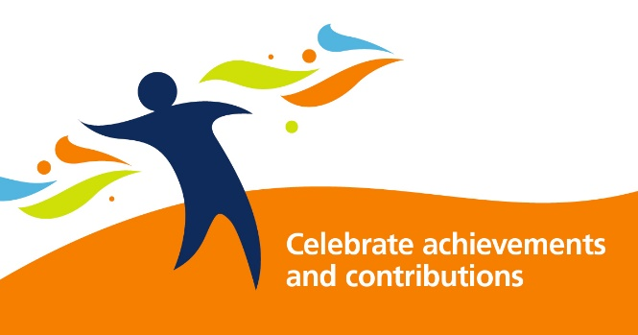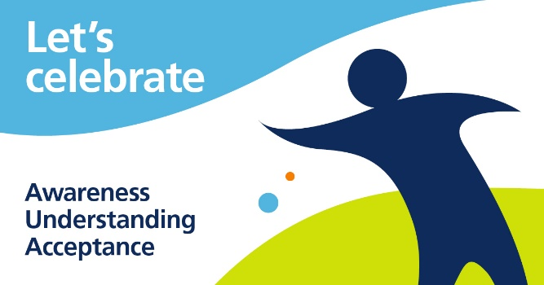
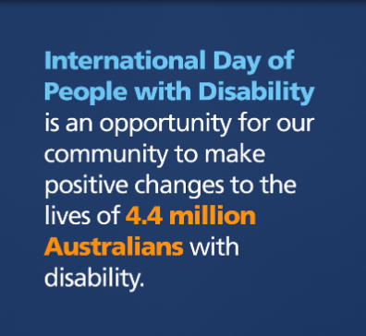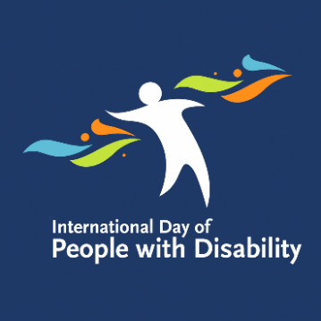
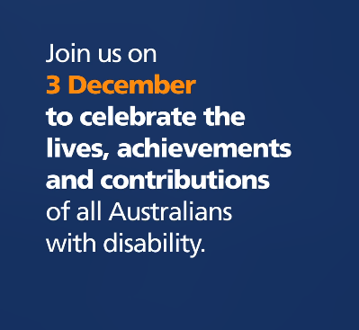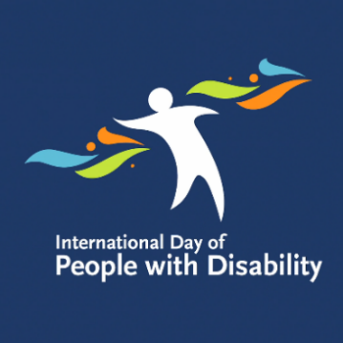

Newsletter article or intranet content
We have included a basic article template for you to customise with details of your IDPwD celebration and share in your staff newsletter or intranet.
Celebrate International Day of People with Disability with [Workplace]
International Day of People with Disability (IDPwD) is a United Nations day held on 3 December each year to celebrate the contributions and achievements of people with disability.
The UN theme for IDPwD this year is ‘Leadership and Participation of persons with disabilities toward an inclusive, accessible and sustainable post-COVID-19 world.’
By acknowledging this important day, we can take action to remove barriers for the
4.4 million Australians with disability and contribute to positive change in our workplace and in the community more broadly.
This year [workplace/organisation] will mark International Day of People with Disability by [insert details of how you will be celebrating].
We encourage all staff to get involved and join the celebration! Together, we can all take action to challenge stereotypes, remove barriers and promote inclusive and respectful attitudes and behaviours in our workplace.
For more information, go to [link to event information] or contact [phone number/email address].
For more information about IDPwD, including resources, stories, videos and social tiles, visit www.idpwd.com.au or follow @idpwd on Facebook and Twitter.
You can also help spread the word and join the conversation online using #IDPwD!

More information
Go to www.idpwd.com.au to find out more and access the latest news, stories and resources. You can also subscribe to receive updates.
Follow @idpwd on Facebook and Twitter and use the hashtag #IDPwD to join the conversation online.
You can also email us at idpwd@dss.gov.au or call us on 1800 440 385 (TTY users, phone 1800 555 677 and ask for 1800 440 385).

