International Day of People with Disability Event planning and teaching resources kit for schools

What’s in this pack?
What is International Day of People with Disability? 3
Event registration 4
Entering the IDPwD Grow Inclusion schools competition 5
Event ideas 6
Event tips 7
Event planning checklist 8
On the day 9
No time to organise an event? 9
Teaching resources 10
Images 12
Posters 12
Banners 12
Instagram frames 13
Social media images 14
Social media 15
Shell media release 16
Tips for engaging with media 17
Newsletter article 18
Official invitation letter 19
Key messages 20
More information 20

What is International Day of People with Disability?
Every year on 3 December, people around the world take part in International Day of People with Disability (IDPwD), a day to celebrate the achievements of people with disability and promote awareness, understanding and acceptance in the community.
At the heart of IDPwD are the events organisations, schools, community groups, businesses and individuals hold to mark the day – from sausage sizzles and sports days, to fêtes and film festivals.
Every event helps to break down barriers for the 4.3 million Australians with a disability and create a more inclusive community for all.
Schools are a vital part of this
By coming together to celebrate IDPwD, your school can help grow inclusion in the community.
Students can learn about people with disability, recognise the challenges they face, and talk about ways to be more inclusive.
IDPwD also provides an opportunity for schools to celebrate the talents, achievements and positive contributions of people with disability.

But December is a busy time for schools…
As the school year winds up, things get busy and organising an event can be difficult.
Don’t worry! IDPwD school events don’t have to be held on 3 December.
IDPwD isn’t about supporting and celebrating people with disability for a day, it is about using the day to prompt the community to improve practices, break down barriers and celebrate all year round.

Event registration
It’s really important to register your school’s event on the IDPwD website.
When you do, you can request a free school pack including IDPwD products to use on the day, such as seed bookmarks, pens, library bags and lapel pins.
Registered public events will appear in the online IDPwD event calendar and may be advertised through the IDPwD website, Facebook or Twitter accounts.
Events can remain anonymous, but all schools are encouraged to register so we can provide you with support.

There are fun and easy ways to get involved
We invite primary and secondary schools, colleges, students, teachers, principals, school bodies and groups to be part of IDPwD 2019 by:
- Planning an IDPwD event.
- Entering the IDPwD Grow Inclusion schools competition for the chance to win $3,000 in fun and accessible learning resources.
- Spreading the word about IDPwD and the importance of inclusion by starting a conversation or through newsletter articles and social media posts.
- Downloading the teacher resources and activity sheets to help incorporate IDPwD in the classroom.
We encourage schools and students to get creative with their events and activities.

Entering the IDPwD Grow Inclusion schools competition
Schools that hold an IDPwD event in 2019 can also help grow inclusion in their communities by entering the Grow Inclusion schools competition.
You can enter your school in three simple steps:

Step 1: Register — head to the IDPwD website to register an event and sign up for the Grow Inclusion schools competition.

Step 2: Celebrate — hold the event between 22 July and 8 November, start a conversation about disability, and have some fun!

Step 3: Get social — post photos or video of the event on your school’s Facebook page.

Your photos or video of the event must be posted on your school’s Facebook page by 5pm AEDT 8 November 2019 to be counted in the competition.
Competition entries will be judged by a committee, who will visit your school’s Facebook page to see photos or video of the event.
Events will be judged on:
- inclusivity and accessibility.
- awareness raised.
- student engagement.
- creativity and innovation.

Schools, year groups and classrooms are eligible to enter.

The winning school will receive $3,000 in accessible resources and materials for its students, as well as promotion on Facebook.

The winner will be announced on 3 December.

Event ideas
Stuck for ideas on what kind of event to run? This list will help you get started.
Activity | Description
Art class | - Run an art class painting with restricted senses e.g. without use of your hands or blindfolded.
Awareness in action | - Put up posters to celebrate and take a group photo to post on Facebook www.facebook.com/idpwd
Concert | - Hold a concert to mark the day, it could feature people with disability or you could provide discounted tickets for people with disability.  - Don’t forget to make sure the venue is accessible.
Fundraising | - Help out a charity organisation associated with providing services and supports for people with disability and undertake a funding drive or identify a volunteering opportunity.
Guest speaker | - Organise a guest speaker to talk about disability or to share their story to inspire others.
Morning tea | - Host a morning tea to mark the day.  - Invite a person with disability and/or your local member of parliament to speak.
Sport game | - Run a sports game like seated volleyball, wheelchair basketball, goalball, treasure hunt relay (in a wheelchair), wheelchair dancing, bushwalk with blindfolds, or navigate the playground.
Sausage sizzle | - Hold a sausage sizzle to mark the day. Every dollar can support a local organisation helping people with disability.
Film screening | - Hold a Focus on Ability film screening.  - There are lots of films to choose from online, that focus on the stories of people with a disability.
Seed planting | - Use the seed bookmarks from your IDPwD schools pack to organise a seed planting activity.

Event tips
Now you are ready to hold an event, here are a few tips to get you on your way.
Set your goal
Decide what you want to achieve from your event.
Enlist some help
Many hands make light work. Consider getting help to organise things like speakers, catering or entertainment.
Name it
Think of a catchy name that captures the spirit of your event.
Location, location
Make sure your chosen venue has wheelchair access, accessible toilets, lifts, parking spaces for people with disability and a hearing loop, if required. Do you need a microphone or staging? Do you have a wet weather contingency plan if it will be held outside?
Official invitations
Consider inviting a member of parliament to open your event and get involved in the celebrations. Identify local community leaders and personalities—such as sporting stars or local musicians to invite to your event. Try to find a business sponsor willing to lend a hand and support your event. Ask invited guests to indicate any assistance they may need (e.g. carer or interpreter, or dietary needs).
Entertainment
Will your event include entertainment? Think about ways to appeal to your audience e.g. speakers, performers, musicians and/or interactive activities.
Make it official
Register your event at www.idpwd.com.au to help you spread the word about your celebration. All events will be published on the website. You can also find out what else is happening in and around your local area by checking out the events calendar.
Promotion
How will you tell people about your event? Will you use social media and posters? What kind of signage will you use at the event? We encourage you to tag the IDPwD Facebook page or use the hashtag when promoting your event through Facebook.
Using the media
Using the media can be helpful in promoting your event, or to spread the word about your celebration. Some people find contacting the media daunting, but it doesn’t need to be. To get you started we have provided a shell media release and some tips to guide you.

Event planning checklist
This checklist will help you to plan, promote and celebrate your event and associated activities. All the information you need to complete this checklist can be found in this kit.
Plan your celebration
Have you chosen your International Day of People with Disability event?
Have you told everyone who will be involved in planning your event?
Make it official
Have you registered your event on the IDPwD website and entered the Grow Inclusion schools competition?
Invite guests
Have you sent out your event invitations?
Have you invited officials, community leaders, local stars or speakers?
Make some noise
Have you applied the IDPwD style guide and logo to your materials?
Have you placed IDPwD graphics and banners on your website and social media pages?
Engaging the media
Have you edited the shell media release with your event details?
Have you contacted and followed-up with media?
Getting some resources
Have you downloaded and used IDPwD resources?
Have you registered your event online to request IDPwD merchandise?
Connecting with us
Have you connected with us on IDPwD Facebook and IDPwD Twitter?
Have you subscribed to our mailing list on the IDPwD website?

On the day
Here are some extra tips to help you on the day of your event.
Setting up
- Secure all electrical equipment, making sure areas are easily accessible without trip hazards.
- Include chairs with and without arms, to allow for physical limitations.
- Make sure you have identified a safe place where attendees with wheelchairs can arrive.
- Reserve appropriate seating for guests including hearing and vision impaired people, people in wheelchairs, people with guide dogs, interpreters and carers
At the location
- Make sure your signage is large enough and written in Plain English so it’s easy to understand.
- Have people to meet and greet attendees and invited guests.
- Make sure everyone knows where the amenities are and make sure helpers are available to assist where needed.
- Ensure that all your guests are settled and as comfortable as possible.
Communication materials
- Use an accessible font for name tags (as large as possible and a good contrasting colour).
- Use contrasting colours if you are using a PowerPoint presentation (i.e. light coloured text on dark background or dark font on a white background).
- If you are using interpreters, provide them with documents at least one week before the event.
- Hand out written copies of presentations on the day.
- Consider making information available in alternate forms such as Easy English, large print, Audiotape or Braille.

No time to organise an event?
You can still get involved and help to raise awareness of this important day.
Encourage others to hold an event or simply start a conversation about disability to mark the day. One in five people, or 4.3 million Australians, have a disability.
By having a conversation about disability, you can challenge perceptions, educate others and normalise disability in everyday life. We all have a role to play to ensure people with disability have the same opportunities as others to reach their full potential.
You can show your support by planning a lesson using teaching resources from the IDPwD website, or by writing an article for the school newsletter.
Visit the IDPwD website for suggestions on other ways to celebrate, how to start a conversation and make your community more inclusive.

Teaching resources
A huge range of curriculum-aligned lesson ideas and student activity sheets are available on the IDPwD website.
Here’s just some of the lesson ideas:
English
- Students to write a short story about a visit to their favourite place. They cannot describe how the place looks: they must describe how it smells, sounds and feels.
- Students to interview a person with disability, then present the interview as a magazine or newspaper article. Include pictures or photographs. Publish the article in the school newsletter or on the school website.
- Students to analyse how people with disability are portrayed in the media and popular culture (TV, movies, music, books etc.). Do students think these portrayals are accurate? Discuss findings.
The Arts
- Students to create large posters inviting people to celebrate International Day of People with Disability. Place them around the school for parents and visitors to see.
- Students to research famous artists with disability and try painting in their styles.
- Students to brainstorm and research ways in which people who are deaf enjoy music. Consider vibrations and movement.
Health and Physical Education
- Students to work in small groups to modify their favourite sport so it can be played by people with disability. For example, modify dodge ball so everyone is sitting down instead of standing.
- Students to research one sport from the Paralympic Games. Teach the sport to the rest of the class.
- Students to discuss the question ‘What does it mean to have disability?’ Record the responses and discuss any stereotypes that are apparent. This should be an open and honest discussion without judgement.

Activity sheet example
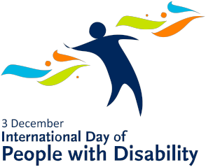
Braille Alphabet Template

Name:

Use this Braille alphabet template to write a short message using raised dots. (Your teacher will give you ideas on how to produce the raised dots.)

a b c d e f g

h I j k l m n

o p q r s t u

v w x y z

OO OO OO OO OO OO OO OO
OO OO OO OO OO OO OO OO
OO OO OO OO OO OO OO OO
___ ___ ___ ___ ___ ___ ___ ___

OO OO OO OO OO OO OO OO
OO OO OO OO OO OO OO OO
OO OO OO OO OO OO OO OO
___ ___ ___ ___ ___ ___ ___ ___

Images
A comprehensive range of posters and social media images are available on the International Day of People with Disability website.
To get you started here are some images for social media, newsletters and websites.

Posters
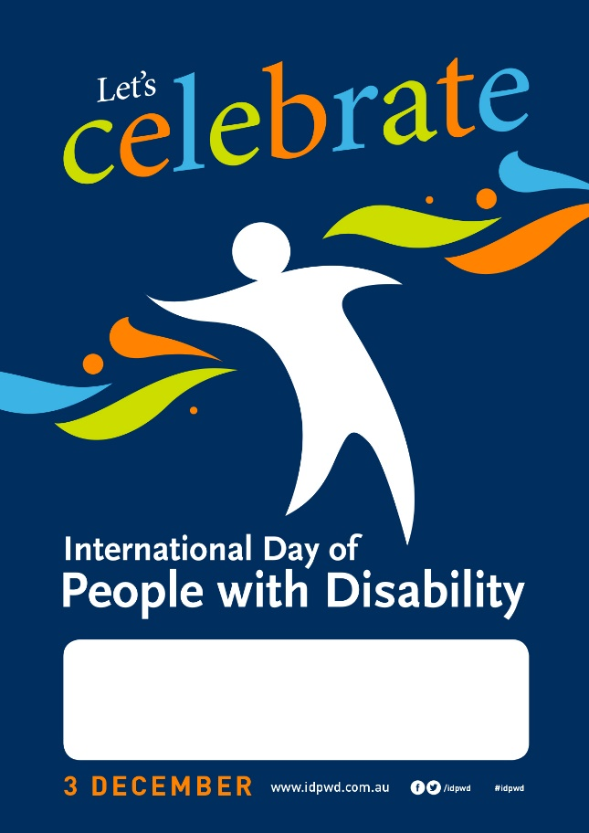

Banners

Instagram frames
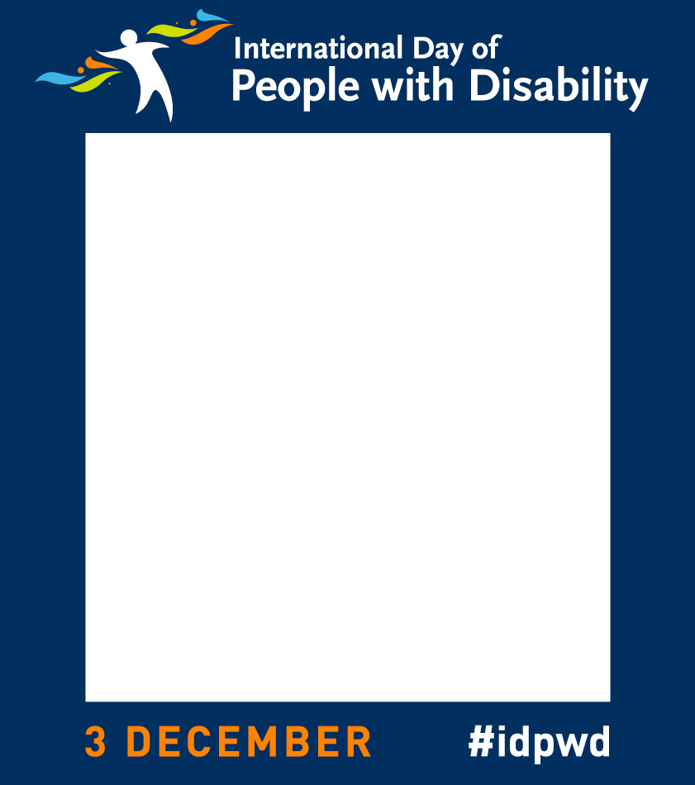

Social media images
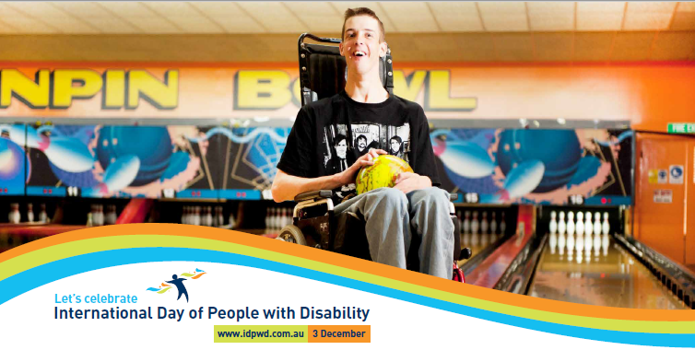
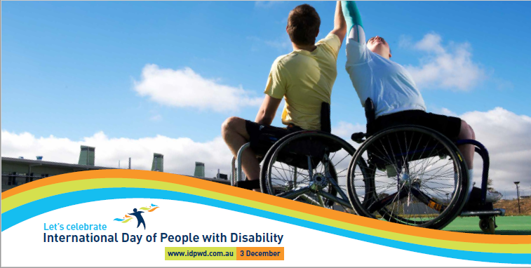
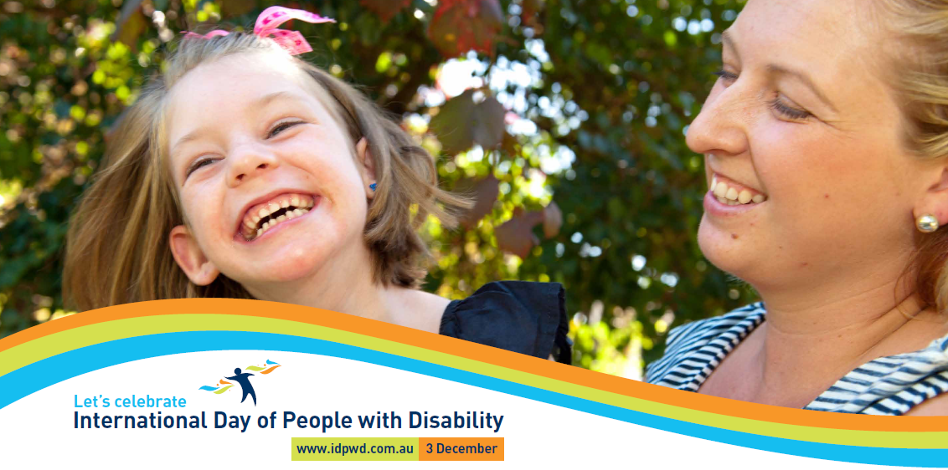

Social media
Social media can be a great tool to spread the word about IDPwD in your community. We have provided a few suggested posts to get you started.
Facebook
Post example #1 | We’re holding an event to celebrate 2018 International Day of People with Disability! Join us for a day of fun and conversation [link to event details] #idpwd #GrowInclusion
Post example #2 | International Day of People with Disability is nearly here – only [x] sleeps to go until 3 December. [School] can’t wait to celebrate and recognise the wonderful contributions people with disability make to this country. Find out more at [registered event web link]. #idpwd #GrowInclusion
Post example #3 | Today we celebrate International Day of People with Disability. Join us for [details of the event]. The time is now to break down barriers and help build awareness and understanding of people with disability. Find out more at [registered event web link]. #idpwd #GrowInclusion
Post example #4 | Look how we celebrated International Day of People with Disability! Our school held a [details of the event] to help grow inclusion in our community.  [Insert event photographs] #idpwd #GrowInclusion
Twitter
Tweet example #1 | We’d love you to join us for [event name] at [location] on [date] to celebrate #idpwd. Find out more [registered event web link]. #GrowInclusion
Tweet example #2 | Join us on [event date] for [event name] as we celebrate #idpwd. Check out [registered event web link]. #GrowInclusion
Tweet example #3 | #idpwd is on 3 December. Visit [registered event web link] to find out how you can help us celebrate. #GrowInclusion
Tweet example #4 | Thank you to everyone who joined us on #idpwd to celebrate the achievements of people with disability. [Insert event photographs] #GrowInclusion

Shell media release

[School] celebrates International Day of People with Disability

[School] is celebrating International Day of People with Disability on [date].
[Spokesperson] for [school] said, “It is important we work to ensure everyday inclusion for the 4.3 million Australians living with disability
“Together we can start a conversation about the issues experienced by people with disability to help to make our community more inclusive.
“This year [School] will mark the International Day of People with Disability by holding [event name] at [venue] on [date].
“There will be [briefly outline activities, i.e. music, food, entertainment] suitable for [all ages/families],” [School spokesperson] said.
[If event is public] “Our event is accessible and we encourage all people with disability, their families and carers to come along and join the fun.”
Thousands of schools have held International Day of People of Disability registered events across Australia since its inception in 1992.
“We are pleased to represent [Community/Location] as part of this important initiative and we are looking forward to doing our bit to make a positive impact on the lives of people with disability.”
[School] has also entered the International Day of People with Disability Grow Inclusion schools competition, and is in the running to win $3,000 in accessible resources, while helping to break down barriers, promote respect and create a more inclusive society for everyone.
For more information about [school event], visit [website address] or contact [phone number/email address].
To learn more about other ways you can celebrate visit www.idpwd.com.au
Facebook www.facebook.com/idpwd
Twitter www.twitter.com/idpwd
#idpwd #GrowInclusion

Tips for engaging with media
The media is a great way to help spread the word of your event or activity.
Step 1 – Prepare your media release
A media release outlines the newsworthy points about your event. We have provided you with a shell media release to get you started.

Things to remember:
- Quote it – Include a quote from the spokesperson or head of your organisation.
- Keep it concise – Keep the release to one page and use clear language.
- Make it stand out – Highlight why your event is newsworthy.
If you don’t host an event, but want to help promote the day, you could also think of a local disability champion or a human interest story to share with local media.

Step 2 – Who to contact?
Now you have your media release, you can contact local publications and journalists who may be interested in finding out about your event.

- Find local media outlets. Start with a Google search. You should be able to find contact details for journalists on the outlet’s website or Twitter pages.
- Where is your event? Local media are most likely to be interested in events held where their publication is distributed.
- What type of event is it? Journalists often have particular subject matters that they cover, for example sports, education, health, disability interest.

Step 3 – Reach out
It’s best to contact journalists two weeks before your event and provide them with a copy of your media release and the interview details of a key spokesperson.
Print and online journalists particularly like images. You could offer photos of previous events or you could explain why this year’s event would make a great photo opportunity.
When you call the news desk, introduce yourself and outline the key points that make your event newsworthy.
Step 4 — Follow up
Keep in touch with media and confirm their attendance the day before your event.
Following the event, don’t forget to check media publications for any coverage you have received.

Newsletter article

Celebrate International Day of People with Disability with [School]

International Day of People with Disability is a United Nations day that promotes inclusivity and celebrates the achievements and contributions of people with disability.
By gathering together to celebrate this day, we can help to ensure inclusion for the
4.3 million Australians living with disability and contribute to positive change in our community.
This year [School] will mark the International Day of People with Disability by holding [event name] at [venue] on [date].
There will be [briefly outline activities, i.e. music, food, entertainment] suitable for [all ages/families].
Our event is accessible and we encourage all students, their families and carers to come along and join the fun.
We’ll also be entering the International Day of People with Disability Grow Inclusion schools competition, for the chance to win $3,000 in accessible prizes, while helping to break down barriers, promote respect and create a more inclusive society for everyone.
Make sure you visit the school Facebook page to see how we celebrated!
Thousands of community organisations have held International Day of People of Disability registered events across Australia since its inception in 1992.
For more information about [school event], go to [website address] or contact [phone number/email address].
Facebook www.facebook.com/idpwd
Twitter www.twitter.com/idpwd
#idpwd #GrowInclusion

Official invitation letter

<Your Name>
<Street Address>
<SUBURB STATE>
<Postcode>
<Phone>
<Email>
<Website>

<Date>
<Recipient Name>
<Title>
<Company Name>
<Street Address>
<SUBURB> <STATE> <Postcode>

Dear [Salutation] [Last Name]
I am writing to invite you to [officially open/ speak at/ attend] our event to mark International Day of People with Disability on [date].
By gathering to celebrate this day, we can ensure inclusion for the 4.3 million Australians living with disability and contribute to positive change in our community.
[School] is planning to hold [event name] at [location] on [date].
There will be [briefly outline activities, i.e. music, food, entertainment] suitable for [all ages/families].
International Day of People with Disability is held each year on 3 December. It is a day that aims to increase public awareness, understanding and acceptance of people with disability. It’s also a celebration of the contribution people with disability make to the community.
Please RSVP by [RSVP date]. For more details please contact [Name] on [phone number] or via email [contact email address].
To find out more about International Day of People with Disability go to the website www.idpwd.com.au
I look forward to your involvement.
Kind regards,
[Head of School]

Key messages
- We’re proud to host an event to celebrate International Day of People with Disability.
- International Day of People with Disability, celebrated on 3 December, is an opportunity for our community to make positive changes to the lives of 4.3 million Australians with disability.
- International Day of People with Disability is a United Nations sanctioned day that promotes an understanding of the issues experienced by people with disability and celebrates their achievements.
- We encourage you to show your support and join us as we work to grow an inclusive society for everyone.
- Make sure you visit the school Facebook page to see how we celebrated the day.
- Help us challenge perceptions and educate others.
- Let’s grow inclusion in our community. To learn more about IDPwD and get involved visit www.idpwd.com.au.

More information

Website: www.idpwd.com.au

Telephone: 1800 440 385

TTY Users: Please phone 1800 555 677 and ask for 1800 440 385

Email: idpwd@dss.gov.au

Facebook: www.facebook.com/idpwd

Twitter: www.twitter.com/idpwd

