Event Planning Kit

Government

What is in this pack?
What is in this pack? 2
What is International Day of People with Disability? 3
Help us to spread the word 3
Event ideas 4
Event tips 5
Event planning checklist 6
On the day 7
Posters 8
Banners 8
Instagram frames 9
Social media images 10
Event invitation 11
Social media 12
Shell media release 13
Tips for engaging with media 14
Newsletter article 15
Official invitation letter 16
Key messages 17
Useful links 17
More information 18

What is International Day of People with Disability?
International Day of People with Disability (IDPwD) is a United Nations sanctioned day held each year on 3 December.
It is a day that aims to increase public awareness, understanding and acceptance of people with disability.
Thousands of registered events have been held across the country since the inception of International Day of People with Disability in 1992.
In Australia, the National Disability Strategy 2010–2020 provides a ten-year national policy framework for all levels of government to improve the lives of people with disability.

Help us to spread the word
The best way to celebrate is to hold an event at your community group.
By together to celebrate this day and talking about disability, you will help to break down barriers for the 4.3 million Australians living with disability and contribute to positive change in your community.
An IDPwD event should involve and celebrate people with disability and be held on or around 3 December.
In this event planning kit, you will find a range of useful links and resources to help you plan and promote your event. You can also download posters, banners, icons and website buttons from the International Day of People with Disability resources web page.
International Day of People with Disability is your opportunity to challenge perceptions and educate others.
Website www.idpwd.com.au
Facebook www.facebook.com/idpwd
Twitter www.twitter.com/idpwd
#idpwd

Event ideas
Stuck for ideas on what kind of event to run? This list will help you get started.
Activity | Description
Art show | - Ask local artists to dedicate an art show. Or develop a piece of art on the lives of people with disability.
Awards | - Acknowledge the achievements of people with disability and those making positive contributions. E.g. recognise accomplishments of students or sportspeople, or businesses with good disability access.
Awareness in action | - Put up posters to celebrate and take a group photo to post on Facebook www.facebook.com/idpwd.
Breakfast or brunch | - Host a breakfast or brunch to mark the day.  - Invite a person with disability and/or your local member of parliament to speak.
Concert | - Hold a concert to mark the day, it could feature people with disability or you could provide discounted tickets for people with disability.  - Don’t forget to make sure the venue is accessible.
Expo | - A disability expo where local organisations with a connection to disability can set-up stalls with information about goods and services.
Fundraising | - Help out a charity organisation associated with providing services and supports for people with disability and undertake a funding drive or identify a volunteering opportunity.
Guest speaker | - Organise a guest speaker to talk about disability or to share their story to inspire others.
Lunch | - Host a lunch to mark the day.  - Invite a person with disability and/or your local member of parliament to speak.
Morning tea | - Host a morning tea to mark the day.  - Invite a person with disability and/or your local member of parliament to speak.
Sausage sizzle | - Hold a sausage sizzle to mark the day.  - Every dollar can support a local organisation helping people with disability.

No time to organise an event?
You can still get involved and help to raise awareness of this important day.
Encourage others to hold an event or simply start a conversation about disability to mark the day. One in five people, or 4.3 million Australians, have a disability. By having a conversation about disability, you can challenge perceptions, educate others and normalise disability in everyday life. We all have a role to play to ensure people with disability have the same opportunities as others to reach their full potential.
You can show your support by writing a newsletter article or sending an opinion piece to your local newspaper.
Visit the IDPwD website for suggestions on other ways to celebrate, how to start a conversation and make your community more inclusive.

Event tips
Now you are ready to hold an event, here are a few tips to get you on your way.

Set your goal
Decide what you want to achieve from your event.

Enlist some help
Many hands make light work. Consider getting help to organise things like speakers, catering or entertainment.

Name it
Think of a catchy name that captures the spirit of your event.

Location, location
Make sure your chosen venue has wheelchair access, accessible toilets, lifts, parking spaces for people with disability and a hearing loop, if required. Do you need a microphone or staging? Do you have a wet weather contingency plan if it will be held outside?

Official invitations
Consider inviting a member of parliament to open your event and get involved in the celebrations. Identify local community leaders and personalities—such as sporting stars or local musicians to invite to your event. Try to find a business sponsor willing to lend a hand and support your event. Ask invited guests to indicate any assistance they may need (e.g. carer or interpreter, or dietary needs).

Entertainment
Will your event include entertainment? Think about ways to appeal to your audience e.g. speakers, performers, musicians and/or interactive activities.

Make it official
Register your event at www.idpwd.com.au to help you spread the word about your celebration. All events will be published on the website. You can also find out what else is happening in and around your local area by checking out the events calendar.

Promotion
How will you tell people about your event? Will you use social media and posters? What kind of signage will you use at the event?

Using the media
Using the media can be helpful in promoting your event, or to spread the word about your celebration. Some people find contacting the media daunting, but it doesn’t need to be. To get you started we have provided a shell media release and some tips to guide you.

Event planning checklist
This checklist will help you to plan, promote and celebrate your event and associated activities. All the information you need to complete this checklist can be found in this kit.

Plan your celebration
Have you chosen your International Day of People with Disability event?
Have you told everyone who will be involved in planning your event?

Make it official
Have you registered your event on the IDPwD website?

Invite guests
Have you sent out your event invitations?
Have you invited officials, community leaders, local stars or speakers?

Make some noise
Have you applied the IDPwD style guide and logo to your materials?
Have you placed IDPwD graphics and banners on your website and social media pages?

Engaging the media
Have you edited the shell media release with your event details?
Have you contacted and followed-up with media?

Getting some resources
Have you downloaded and used IDPwD resources?
Have you registered your event online to request IDPwD merchandise?

Connecting with us
Have you connected with us on IDPwD Facebook and IDPwD Twitter?
Have you subscribed to our mailing list on the IDPwD website?

On the day
Here are some extra tips to help you on the day of your event.

Setting up
- Secure all electrical equipment, making sure areas are easily accessible without trip hazards.
- Include chairs with and without arms, to allow for physical limitations.
- Reserve appropriate seating for guests including hearing and vision impaired, interpreters and carers, wheelchairs and guide dogs.

At the location
- Make sure your signage is large enough and written in Plain English so it’s easy to understand.
- Ensure that all your guests are settled and as comfortable as possible.
- Make sure you have identified a safe place where attendees with wheelchairs can arrive.
- Have people to meet and greet attendees and invited guests.
- Make sure everyone knows where the amenities are and make sure helpers are available to assist where needed.

Communication materials
- Use an accessible font for name tags (as large as possible and a good contrasting colour).
- Use contrasting colours if you are using a PowerPoint presentation (i.e. light coloured text on dark background or dark font on a white background).
- If you are using interpreters, provide them with documents at least one week before the event.
- Hand out written copies of presentations on the day.
- Consider making information available in alternate forms such as Easy English, large print, Audiotape or Braille.

Posters
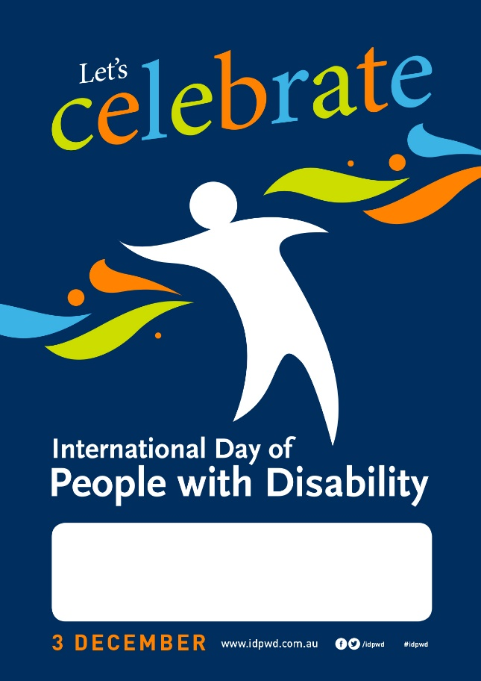

Banners
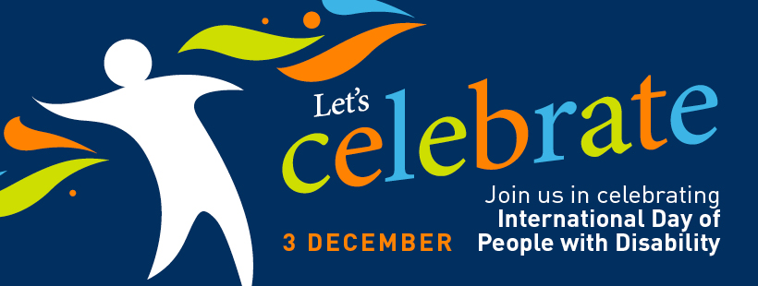

Instagram frames

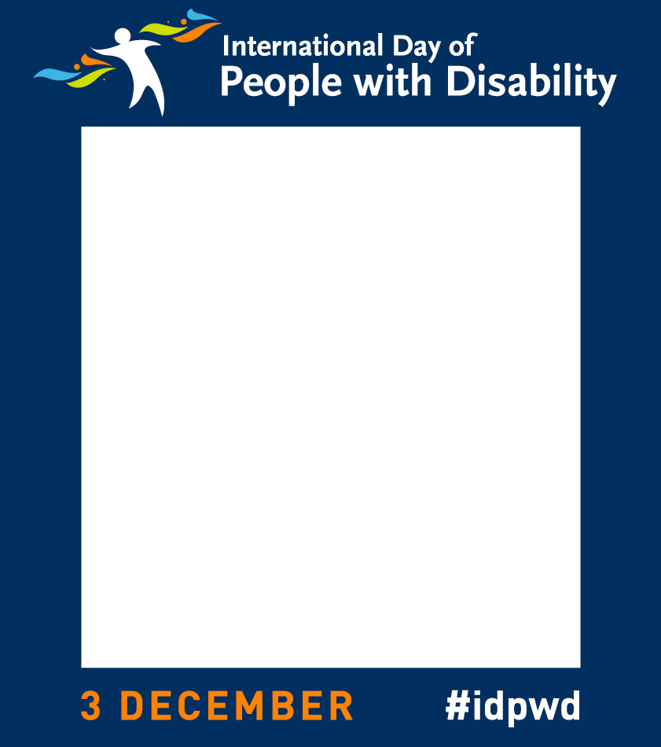

Social media images
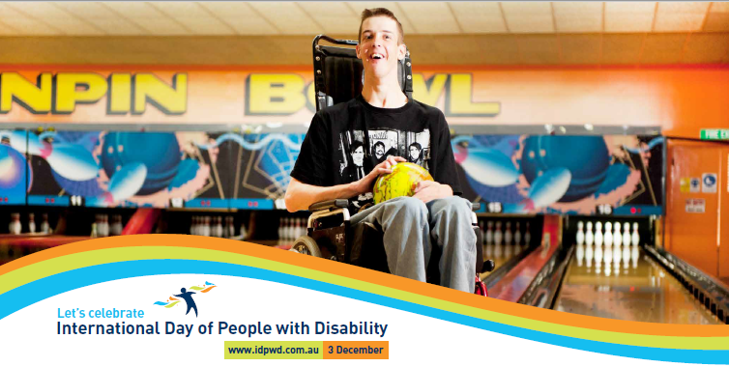

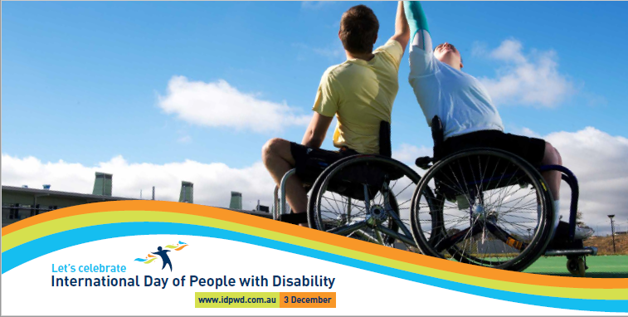

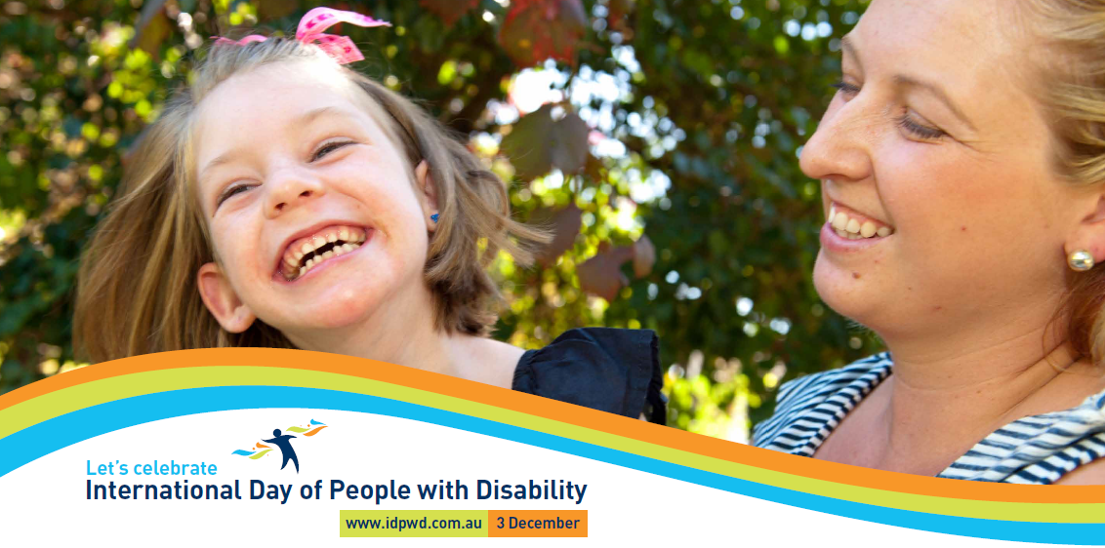

Event invitation

Download the complete range of event invitations, posters, banners, images and invitations from the International Day of People with Disability website

Social media
Social media can be a great tool to spread the word in your community. We have provided a few suggested posts to get you started.

Facebook
POST EXAMPLE #1 | We’re holding an event to celebrate 2018 International Day of People with Disability! Join us for a day of fun and conversation [link to Facebook event] #idpwd
POST EXAMPLE #2 | International Day of People with Disability is nearly here – only [x] sleeps to go until 3 December. [Community/Organisation] can’t wait to celebrate and recognise the wonderful contributions people with disability make to this country. Find out more at [registered event web link]. #idpwd
POST EXAMPLE #3 | Today marks International Day of People with Disability. Join us for [details of the event]. The time is now to break down barriers and help build awareness and understanding of people with disability. Find out more at [registered event web link]. #idpwd
POST EXAMPLE #4 | Thank you to everyone who joined us on [details of the event] to celebrate International Day of People with Disability. With your support we are helping to make positive changes to the lives of 4.3 million Australians. [Insert event photographs]

Twitter
TWEET EXAMPLE #1 | We’d love you to join us for [event name] at [location] on 3 December to celebrate #idpwd. Find out more www.idpwd.com.au
TWEET EXAMPLE #2 | Join us on [event date] for [event name] as we celebrate #idpwd. Check out [registered event web link].
TWEET EXAMPLE #3 | #idpwd is on 3 December. Visit [registered event web link] to find out how you can help us celebrate.
TWEET EXAMPLE #4 | Thank you to everyone who joined us on #idpwd to celebrate the achievements of people with disability.

Shell media release

[Local Council] celebrates International Day of People with Disability
[Local Council] is celebrating International Day of People with Disability on [3 December or alternative date].
[Mayor/Spokesperson] for [Local Council] said, “It is important we work to ensure everyday inclusion for the 4.3 million Australians living with disability.
“Together we can start a conversation about the issues experienced by people with disability to help to make our community more inclusive.
“This year [Local Council] will mark International Day of People with Disability by holding [event name] at [venue] on [date].
“There will be [briefly outline activities, i.e. music, food, entertainment] suitable for [all ages/families].
“Our event is accessible and we encourage all people with disability, their families and carers to come along and join the fun, [Mayor/spokesperson] said.
Thousands of community organisations have held International Day of People of Disability registered events across Australia since its inception in 1992.
“We are pleased to represent [Community/Location] as part of this important initiative and we are looking forward to doing our bit to make a positive impact on the lives of people with disability.”
For more information about [Local Council event], visit [website address] or contact [phone number/email address].
To learn more about other ways you can celebrate go to www.idpwd.com.au
Facebook www.facebook.com/idpwd
Twitter www.twitter.com/idpwd
#idpwd

Tips for engaging with media
The media is a great way to help spread the word of your event or activity.

Step 1 – Prepare your media release
A media release outlines the newsworthy points about your event. We have provided you with a shell media release to get you started.

Things to remember:
- Quote it – Include a quote from the spokesperson or head of your organisation.
- Keep it concise – Keep the release to one page and use clear language.
- Make it stand out – Highlight why your event is newsworthy.
If you don’t host an event, but want to help promote the day, you could also think of a local disability champion or a human interest story to share with local media.

Step 2 – Who to contact?
Now you have your media release, you can contact local publications and journalists who may be interested in finding out about your event.

- Find local media outlets. Start with a Google search. You should be able to find contact details for journalists on the outlet’s website or Twitter pages.
- Where is your event? Local media are most likely to be interested in events held where their publication is distributed.
- What type of event is it? Journalists often have particular subject matters that they cover, for example sports, education, health, disability interest.

Step 3 – Reach out
It’s best to contact journalists two weeks before your event and provide them with a copy of your media release and the interview details of a key spokesperson.

Print and online journalists particularly like images. You could offer photos of previous events or you could explain why this year’s event would make a great photo opportunity.

When you call the news desk, introduce yourself and outline the key points that make your event newsworthy.

Step 4 — Follow up
Keep in touch with media and confirm their attendance the day before your event.

Following the event, don’t forget to check media outlets publications for any coverage you have received.

Newsletter article

Celebrate International Day of People with Disability with [Local Council]
International Day of People with Disability is a United Nations day that promotes inclusivity and celebrates the achievements and contributions of people with disability.
By gathering together to celebrate this day, we can help to ensure inclusion for the 4.3 million Australians living with disability and contribute to positive change in our community.
This year [Local Council] will mark International Day of People with Disability by holding [event name] at [venue] on [date].
There will be [briefly outline activities, i.e. music, food, entertainment] suitable for [all ages/families].
Our event is accessible and we encourage all people with disability, their families and carers to come along and join the fun.
Thousands of community organisations have held International Day of People of Disability registered events across Australia since its inception in 1992.
For more information about [Local Council event], go to [website address] or contact [phone number/email address].
Facebook www.facebook.com/idpwd
Twitter www.twitter.com/idpwd
#idpwd

Official invitation letter

<Your Name>
<Street Address>
<SUBURB STATE>
<Postcode>
<Phone>
<Email>
<Website>

<Date>
<Recipient Name>
<Title>
<Company Name>
<Street Address>
<SUBURB> <STATE> <Postcode>

Dear [Salutation] [Last Name]
I am writing to invite you to [officially open/ speak at/ attend] our event to mark International Day of People with Disability.
By gathering to celebrate this day, we can help break down barriers for the 4.3 million Australians living with disability and contribute to positive change in our community.
[Local Council] is planning to hold [event name] at [location] on [date].
There will be [briefly outline activities, i.e. music, food, entertainment] suitable for [all ages/families].
International Day of People with Disability is held each year on 3 December. It is a day that aims to increase public awareness, understanding and acceptance of people with disability. It’s also a celebration of the contribution people with disability make to the community.
Please RSVP by [RSVP date]. For more details please contact [Name] on [phone number] or via email [contact email address].
To find out more about International Day of People with Disability go to the website www.idpwd.com.au.
I look forward to your involvement.
Kind regards,
[Mayor/Local Representative]

Key messages
- We’re proud to host an event to celebrate International Day of People with Disability.
- International Day of People with Disability, celebrated on 3 December, is an opportunity for our community to make positive changes to the lives of 4.3 million Australians with disability.
- International Day of People with Disability is a United Nations sanctioned day that promotes an understanding of the issues experienced by people with disability and celebrates their achievements.
- Show your support and join us as we work to ensure inclusion and realise an inclusive society for everyone.
- Let’s start a conversation about the issues experienced by people with disability to help to make our community more inclusive.
- Help us challenge perceptions and educate others.
- To learn more about other ways you can celebrate and get involved go to www.idpwd.com.au

Useful links
- Australian Network on Disability https://www.and.org.au/pages/event-checklist.html
- Meetings & Events Australia http://www.meetingsevents.com.au/downloads/Accessible_Events_Guide.pdf
- People with Disability Australia www.pwd.org.au
- First Peoples Disability Network Australia http://fpdn.org.au/
- National Ethnic Disability Alliance www.neda.org.au
- Women with Disabilities Australia http://wwda.org.au/
- Children and Young People with Disability Australia www.cyda.org.au
- National Rural Health Alliance http://ruralhealth.org.au/
- Carers Australia www.carersaustralia.com.au
- National Disability Services www.nds.org.au
- National Disability Insurance Agency www.ndis.gov.au

More information

Website: www.idpwd.com.au

Telephone: 1800 672 682

TTY Users: Please phone 1800 555 677 and ask for 1800 672 682
Email: idpwd@dss.gov.au

Facebook: www.facebook.com/idpwd
Twitter: www.twitter.com/idpwd

