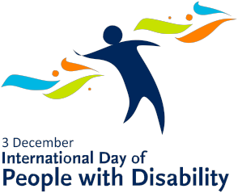

True or False?

Name:
Read the following statements and decide if you think they are true or flase. Circle your answer.
Statement | True/False?
You can recognise a person wth a disability just by looking at them. | True / False
A fighter pilot with disability took part in the Battle of Britain. | True / False
There is no comparable word for ‘disability’ in any traditional Aboriginal or Torres Strait Islander language. | True / False
In ancient times there were no people with disability. | True / False
One of the world’s greatest physicists is a person with disability. | True / False
Speaking and writing are the only ways that people can communicate. | True / False
We can all remove barriers that people face in the community. | True / False
Everyone with disability requires the use of a wheelchair or other equipment. | True / False
Auslan is a language. | True / False
In Egypt there are ancient drawings depicting people with disability. | True / False
The word ‘Paralympic’ comes from the word ‘paraplegic.’ | True / False
Everyone with disability is the same. | True / False
There have been wprld leaders with disability. | True / False
There aren’t many people with disability in Australia. | True / False
All people with a hearing disability can read lips. | True / False

