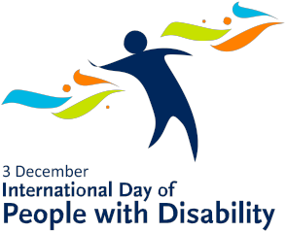

Match me up

Name:
Many well-known people have, or are thought to have had, a disability. Some of these people are listed below. Can you match the person with their occupation? The occupations may be used more than once.
Person | Occupation
Albert Einstein
Ludwig van Beethoven
Christy Brown
Helen Keller
Kurt Fearnley
Frida Kahlo
Louse Braille
Stephen Hawking
John Nash
Christopher Reeves
Walt Disney

Occupation
- Actor
- Artist
- Athlete
- Author/Painter/Poet
- Political Activist
- Composer/Musician
- Mathematician
- Professor
- Scientist
- Cartoonist

