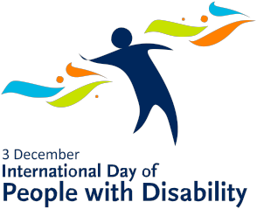

A Celebration of Ability – Option 2

Name:
Fill in the missing letters of these words which contain the word ABLE.
- Feeling at ease and relaxed | _ _ _ _ _ _ _ ABLE
- A piece of furniture | _ ABLE
- Likely to fall over | _ _ _ _ ABLE
- Very likeable | _ _ _ ABLE
- Able to be set on fire | _ _ _ _ _ ABLE
- Thick rope of wires | _ ABLE
- Worth a lot of money | _ _ _ _ ABLE
- Able to be moved from one place to another | _ _ _ _ _ _ _ _ _ ABLE
- Likely to happen | _ _ _ _ ABLE
- Able to be broken down in the environment | _ _ _ _ _ _ _ _ _ ABLE

Fill in the missing letters to make words which contain the letters A, B, L & E:

- To burn brightly | BLA _E
- Keep steady, as when standing on one foot | BAL _ _ _ E
- To mix up or to jumble | _ _ _ A _ BLE
- All the letters of a language | AL _ _ _BE _
- Something you wear on your wrist | BA _ _ LE

