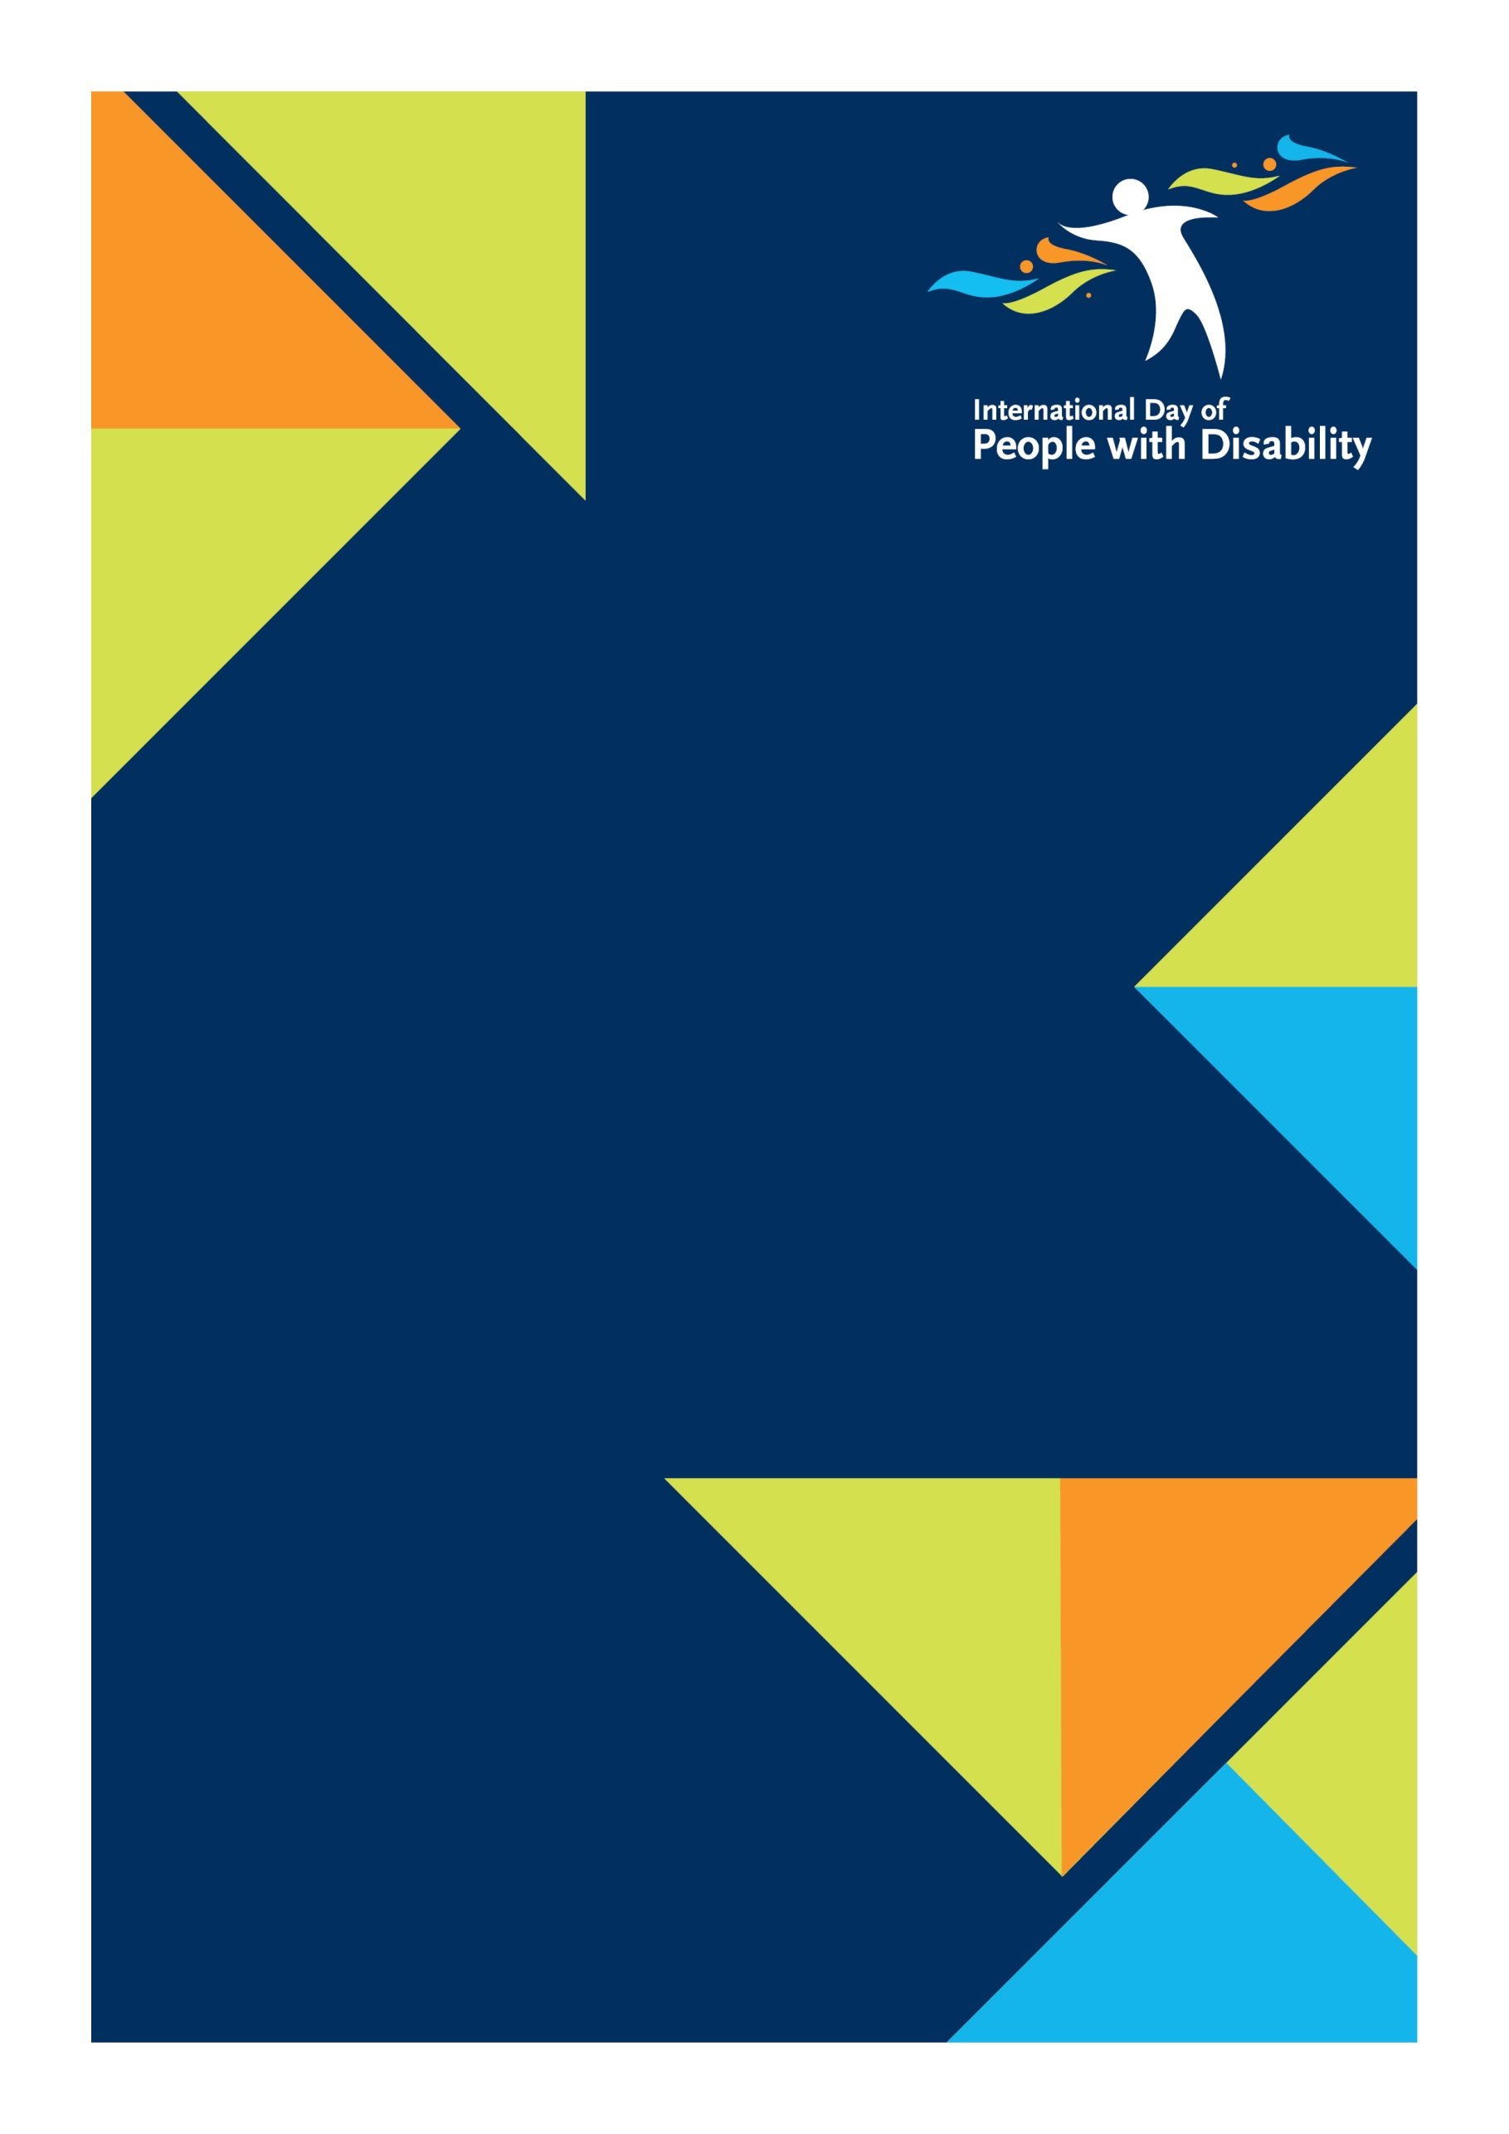
2017 National Disability Awards

Stakeholder Kit
  - ENCOURAGE AWARD NOMINATIONS IN YOUR WORKPLACE OR LOCAL COMMUNITY.
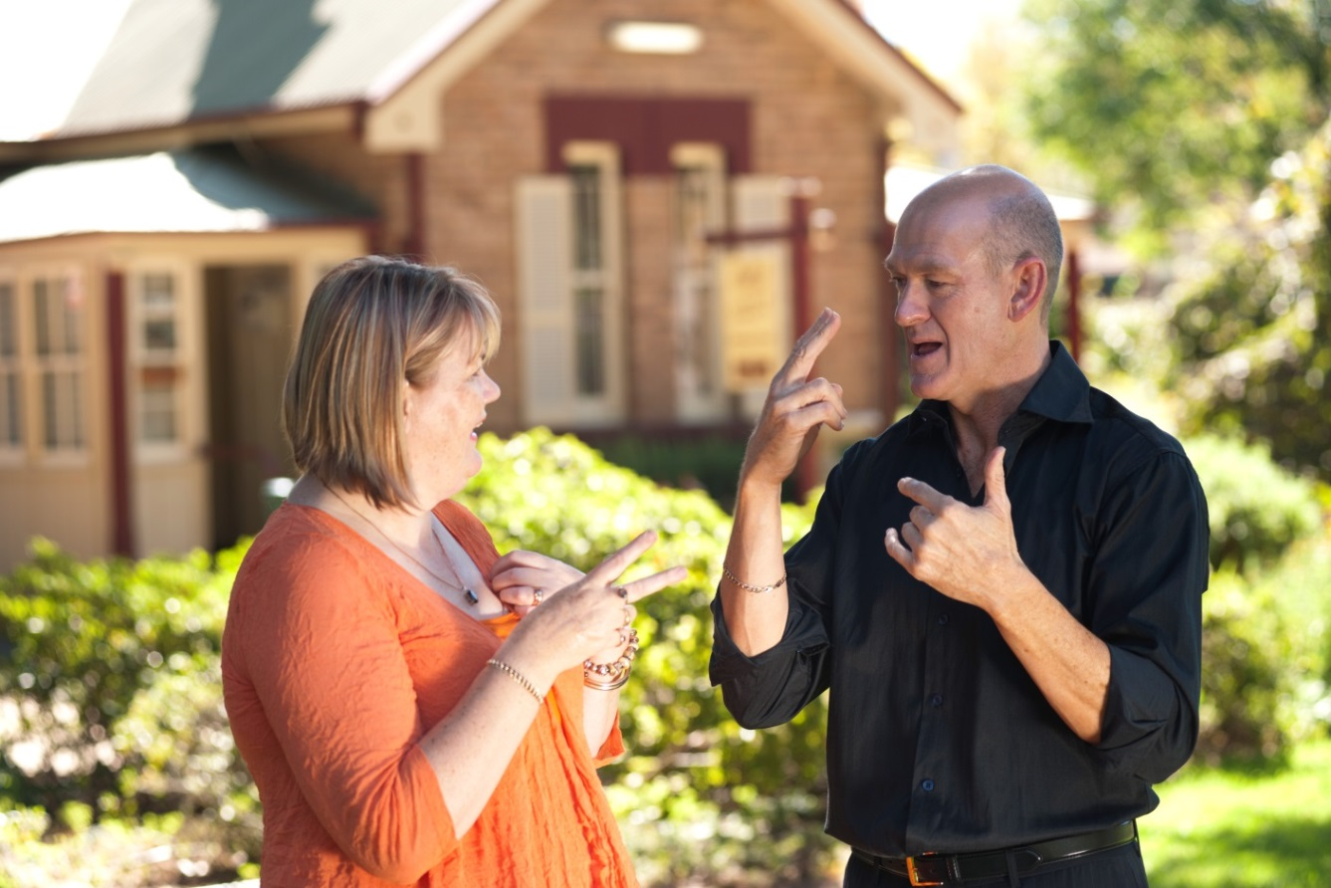

What's in this pack?

Overview 3
Suggested social media content 5
Suggested website content 6
Graphics, buttons and banners 7
Posters 9
Video 10
Shell media release 11
Newsletter article 12
Letter to prospective nominees 13
Testimonials 14
FAQs 16
Further information 17

Overview

What are the National Disability Awards?
The National Disability Awards offer a platform to recognise the efforts being carried out by individuals, teams and organisations that have improved the lives of Australians with disability.
Facilitated by the Department of Social Services, the National Disability Awards Ceremony will be held on 3 December 2017 to coincide with the United Nations sanctioned International Day of People with Disability (IDPwD).

How can you help?
As a key stakeholder we need your support to promote the 2017 National Disability Awards and to spread the word to your members and your local media. Here are some ways you can help us share the news.
Post and tweet | Use the suggested social content below and share on your platforms.
Shout about it on your website | Upload the suggested web copy to your website to encourage your members to nominate for the National Disability Awards.
Share resources | Download a range of posters, graphics, banners and buttons to visually promote the National Disability Awards.
Promotional video | Share our short YouTube video with your members by embedding the video in an email, newsletter or on your website.
Talk to the media | Tailor a media release to help us communicate key messages to your local media.
Include us in your communications | Adapt the newsletter article to communicate with your members or your internal and external networks.
Send a letter | Write to your members and encourage them to nominate for this year’s Awards using the template below.
Winners stories | Share testimonials from last year’s winners to inspire others to nominate this year.

A kit to assist you to promote IDPwD will be provided later in the year.

Key dates
2017 National Disability Awards nominations open | 21 June 2017
2017 National Disability Awards nominations close | 6 August 2017
2017 National Disability Award finalists announced | Early October 2017
2017 National Disability Awards ceremony | 3 December 2017
International Day of People with Disability | 3 December 2017

Award categories
- Lesley Hall Leadership Award – recognises excellence in development of reform opportunities that improve the lives of people with disability.

- Employer of the Year Award – recognises excellence in workforce diversity by providing sustainable employment opportunities for people with disability.

- Community Excellence Award – recognises excellence in improving access and participation in Australian life for people with disability.

- Excellence in Innovation Award – recognises excellence in innovation in services, places, communities or accessible technologies to improve the lives of people with disability.

- Excellence in Education and Training Award - recognises excellence in inclusive education or vocational training that delivers improved economic and social outcomes for people with disability.

Suggested social media content

Twitter
TWEET EXAMPLE #1: Nominations are now open for the #nationaldisabilityawards. Check out www.idpwd.com.au to find out more.
TWEET EXAMPLE #2: Do you know someone creating amazing innovations to help people with disability? Nominate them now for the Excellence in Innovation Award. www.idpwd.com.au
TWEET EXAMPLE #3: Is your workplace providing jobs for people with disability? Nominate them for the Employer of the Year Award. www.idpwd.com.au

Facebook
POST EXAMPLE #1: Have you, your workplace or someone you know improved the lives of Australians with disability? Then enter now for the #nationaldisabilityawards. Check out www.idpwd.com.au to find out more.
POST EXAMPLE #2: The search is on for Australia's number one disability advocate. Do you know someone breaking down barriers in your local community? Play your part in recognising their amazing efforts and nominate them now for the Lesley Hall Leadership Award at this year’s #nationaldisabilityawards. Check out www.idpwd.com.au to find out more.
POST EXAMPLE #3: Last year’s joint winner of the Excellence in Inclusive Service Delivery Award, Determined2, were honoured for their specially designed Immersion Therapy™ Program for people with disability. For your chance to be recognised at the 2017 #nationaldisabilityawards nominate now at www.idpwd.com.au
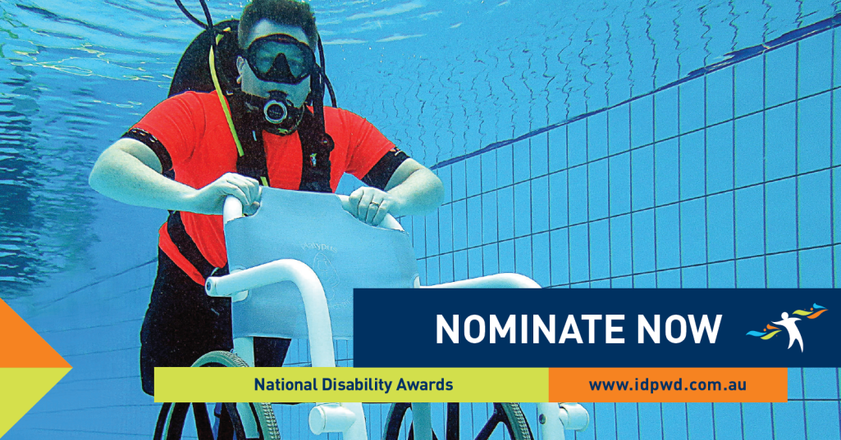

More 2016 images and stories are available from the International Day of People with Disability website

Suggested website content
Do you know someone who is bringing about a change for people with disability?

A nomination for a National Disability Award is a great way to honour individuals and organisations that raise awareness of disability issues within our community.
Help us celebrate those Australians who work tirelessly to reduce social discrimination and uphold the rights of people with disability.
Nominations for the National Disability Awards close at 11.59pm AEST on 6 August 2017.
Nominate now at www.idpwd.com.au.

Website images
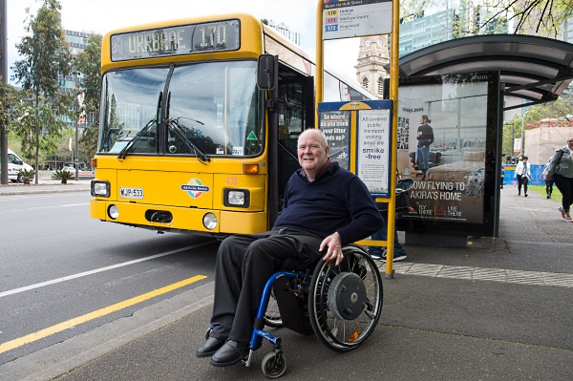

Maurice Corcoran AM, SA, 2016 Winner, Lesley Hall Leadership Award
Maurice Corcoran has been an advocate for people with disability for more than 30 years. In 2006 he was made a member of the Order of Australia for his sustained service to people with disability and contribution to the development of national standards for Accessible Public Transport.

More 2016 images and stories are available from the International Day of People with Disability website

Graphics, buttons and banners
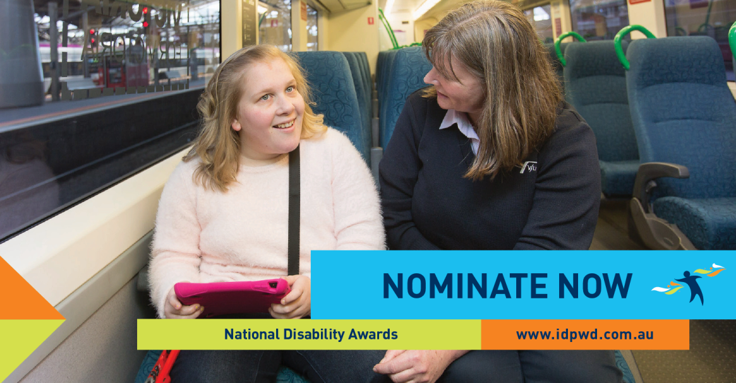
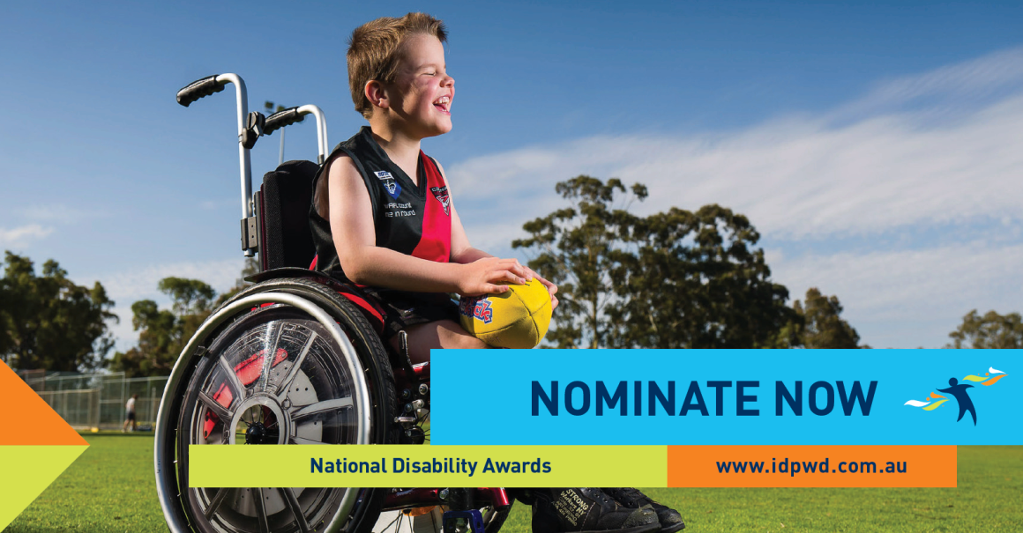
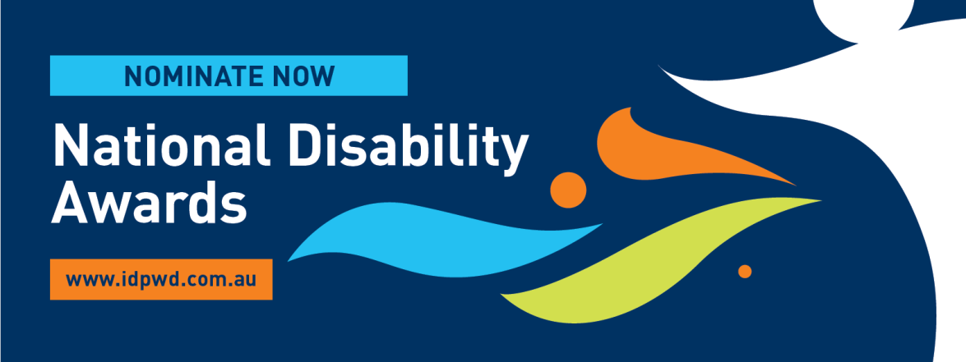

E-card
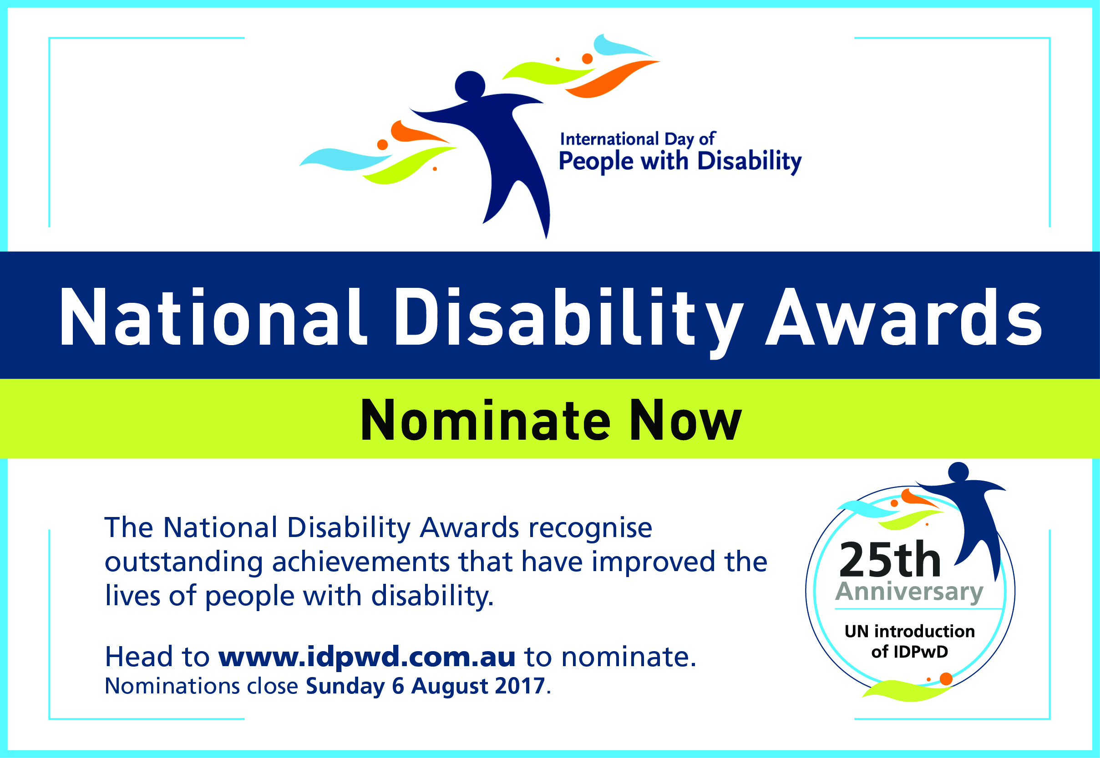

Website button
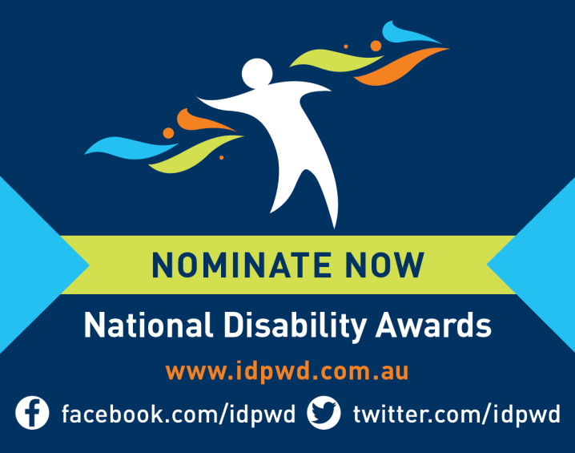

More graphics, buttons and banners are available to download in high resolution from the International Day of People with Disability website

Posters
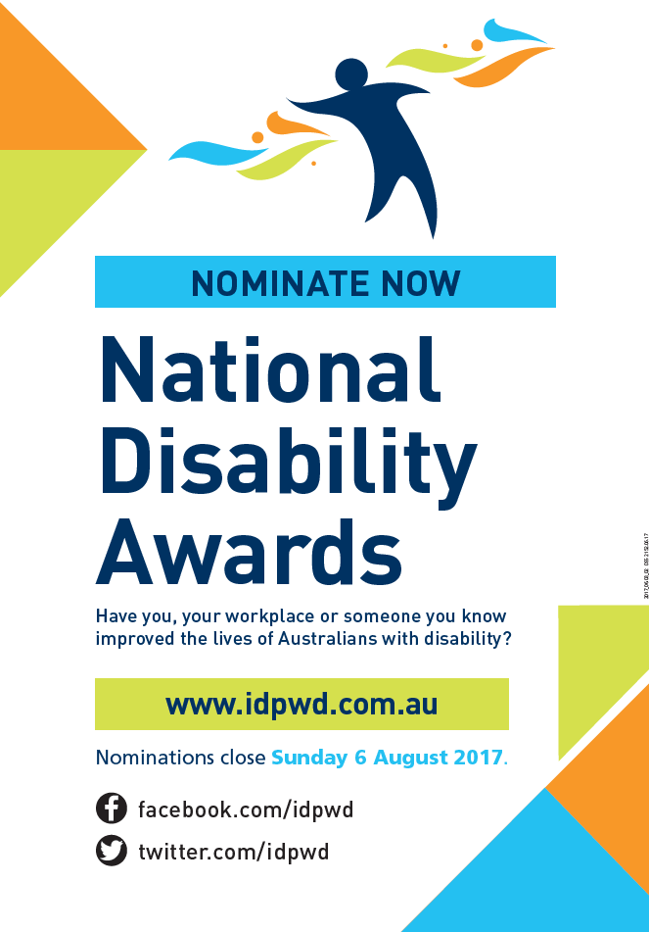

More posters are available to download and print from the International Day of People with Disability website

Video
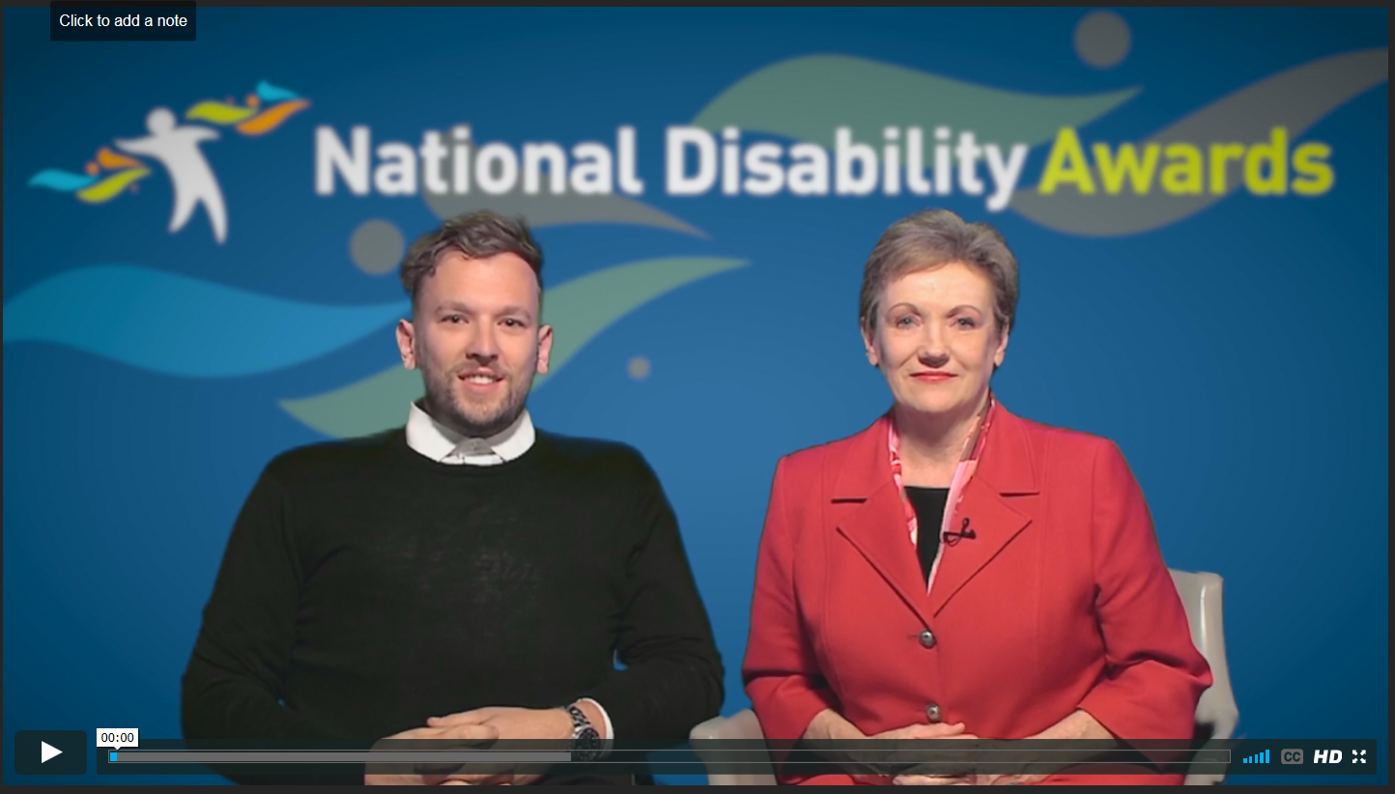
Share the video from the Department of Social Services YouTube channel.
You can easily post the video on your social media channels by selecting the ‘share’ button located under the video player.

Shell media release
[Name of organisation/community group] encourages you to nominate for the
2017 National Disability Awards
[Name of organisation/community group] encourages local [Location] individuals, workplaces and businesses who have improved the lives of Australians with disability, to submit a nomination for the National Disability Awards by 6 August 2017.

Ms/Mr [Name of insert name of organisation/community group] said the Awards offer a platform to highlight the community’s efforts to help break down barriers for people with disability.

“If you know someone who works tirelessly to reduce social discrimination and uphold the rights of people with disability in our community, then I encourage you to nominate them for an award,” Ms/Mr [Name] said.

“It is extremely important that we champion the everyday achievements that are paving the way for an inclusive society for all,” Ms/Mr [Name] continued.

The 2017 National Disability Awards will showcase best practice across the community in five award categories:

- Lesley Hall Leadership Award – recognises excellence in development of reform opportunities that improve the lives of people with disability.

- Employer of the Year Award – recognises excellence in workforce diversity by providing sustainable employment opportunities for people with disability.

- Community Excellence Award – recognises excellence in improving access and participation in Australian life for people with disability.

- Excellence in Innovation Award – recognises excellence in innovation in services, places, communities or accessible technologies to improve the lives of people with disability.

- Excellence in Education and Training Award - recognises excellence in inclusive education or vocational training that delivers improved economic and social outcomes for people with disability.
Winners will be announced at an awards ceremony in Canberra on 3 December 2017.

The 2017 National Disability Awards are part of the Australian Government’s celebration of International Day of People with Disability, a United Nations (UN) sanctioned day celebrated each year on 3 December.

This year, the UN will mark the 25th anniversary of the introduction of this important day around the world.

Nominate now at www.idpwd.com.au Nominations for the Award categories close at 11:59pm AEST on 6 August 2017.

Newsletter article
Nominate now for the 2017 National Disability Awards
Do you know an individual, organisation or project making a difference to the lives of people with disability in [Location of workplace or community group]?

A nomination in this year’s National Disability Awards is a great way to honour and recognise those who work tirelessly to reduce social discrimination and uphold the human rights of people with disability.

The 2017 Categories
- Lesley Hall Leadership Award – recognises excellence in development of reform opportunities that improve the lives of people with disability.

- Employer of the Year Award – recognises excellence in workforce diversity by providing sustainable employment opportunities for people with disability.

- Community Excellence Award – recognises excellence in improving access and participation in Australian life for people with disability.

- Excellence in Innovation Award – recognises excellence in innovation in services, places, communities or accessible technologies to improve the lives of people with disability.

- Excellence in Education and Training Award - recognises excellence in inclusive education or vocational training that delivers improved economic and social outcomes for people with disability.
How can you nominate?

You can submit a nomination online, by email or post. Check out www.idpwd.com.au to find out more.

Nominations close at 11:59pm AEST on 6 August 2017.

Winners will be announced at an awards ceremony in Canberra on 3 December 2017.

Letter to prospective nominees
Dear [Name]

I am writing to let you know that nominations are now open for the 2017 National Disability Award.

The National Disability Awards recognise the incredible endeavours undertaken by individuals, teams and organisations to help improve the lives of people with disability.

Having come across the wonderful efforts carried out by [Individual, business, work], I feel strongly that you are a suitable candidate for a nomination for the following Award category.
[Delete as required]

Lesley Hall Leadership Award – recognises excellence in development of reform opportunities that improve the lives of people with disability.
Employer of the Year Award – recognises excellence in workforce diversity by providing sustainable employment opportunities for people with disability.
Community Excellence Award – recognises excellence in improving access and participation in Australian life for people with disability.
Excellence in Innovation Award – recognises excellence in innovation in services, places, communities or accessible technologies to improve the lives of people with disability.
Excellence in Education and Training Award - recognises excellence in inclusive education or vocational training that delivers improved economic and social outcomes for people with disability.

I encourage you to submit a nomination at www.idpwd.com.au

Nominations for the Award categories close at 11:59pm AEST on 6 August 2017.

If you would like any assistance in submitting a nomination, please contact [Name] by calling [Phone Number] or emailing [Email Address].
I would like to take this opportunity to wish you the very best of luck throughout the nomination process.

Yours sincerely

[Insert title and name of organisation/community group]

Testimonials
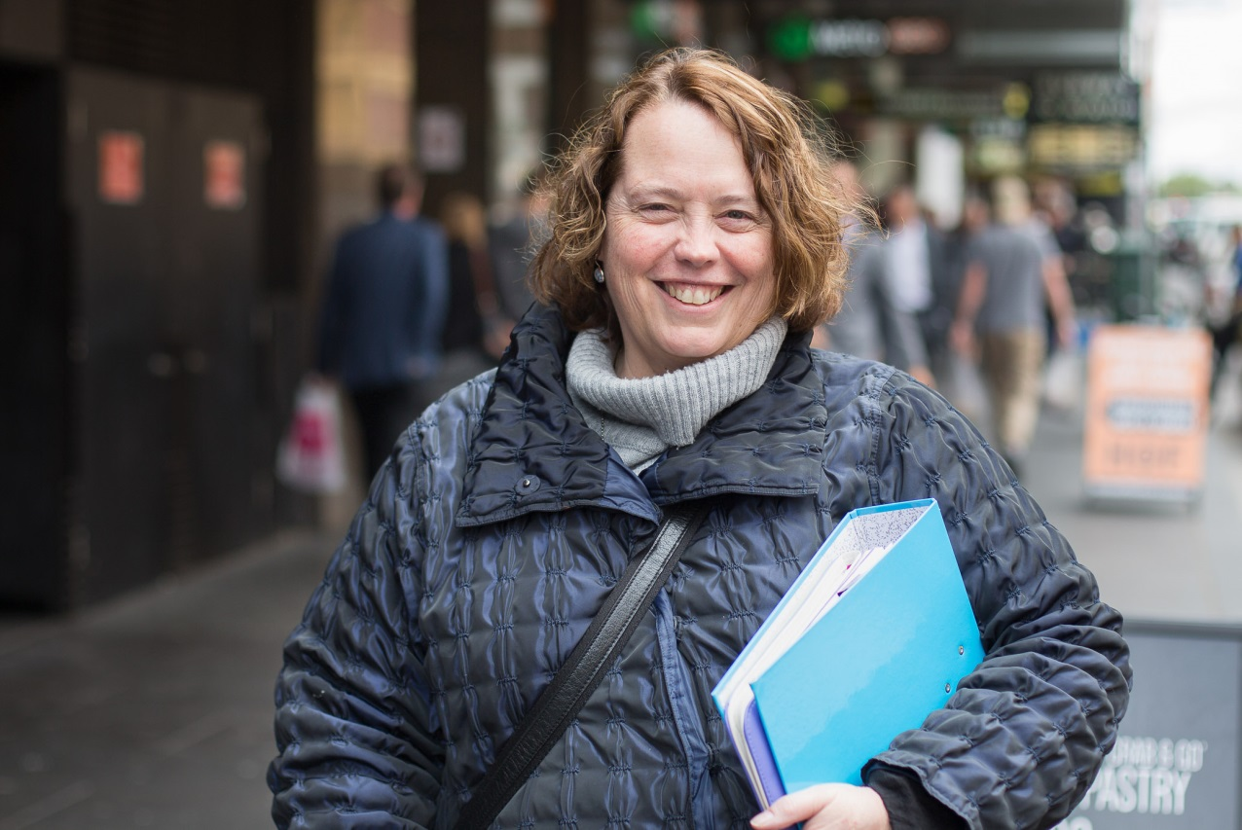

Excellence in Justice and Rights Protection Award
2016 Joint Winner
Kairsty Wilson – AED Legal Centre, VIC

“Winning the 2016 National Disability Excellence in Justice and Rights Protection Award has been a major highlight of my career. At a personal level it has been an acknowledgement by my peers of the quality and value of my work in the area of disability, employment, human rights and anti-discrimination law.

“I think the Award was recognition of the last 10 years of dedicated legal advocacy for people with disability. But over and above that I think that the award brought home a sense of achievement for the long hours, days, months and years spent juggling limited resources, fundraising and the very real needs of our clients to reach the goal of recognition of workplace rights for people with disability.

“At an organisational level, the award was also recognition of the team work of AED Legal Centre and the importance of the issues we cover. I am very privileged to be working with a team of dedicated and highly skilled professionals who continually show an unrelenting commitment to social justice helping disadvantaged individuals.

“Every time we win a case, negotiate an outcome or get a person with disability the help they need we celebrate a little victory. Each victory takes us to a better society where we all live as equals. This Award was recognition of my belief that every person, including those with disability, has the same rights as each other!”

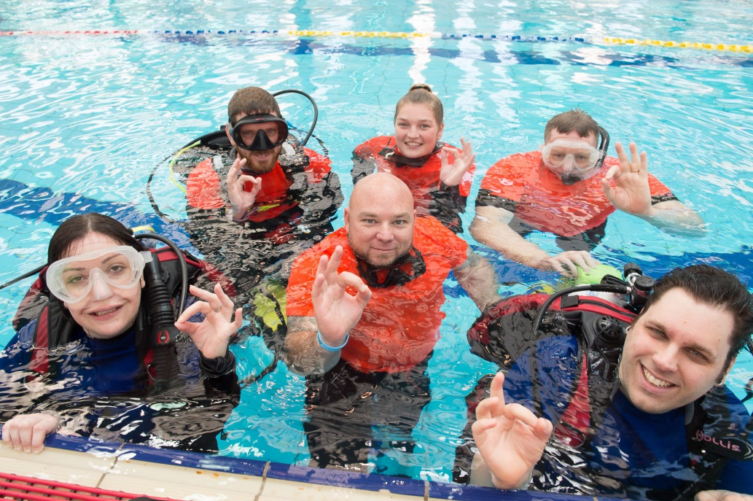

Excellence in Inclusive Service Delivery Award
2016 Joint Winner
Determined2, SA

“My Name is Peter Wilson, Managing Director of Determined2 and founder of the Immersion Therapy service. Last year Determined2 received the Excellence in Inclusive Service Delivery Award at the 2016 National Disability Awards.”

“Winning this award meant so much more to me than a trip to Canberra, a lovely dinner and coming home with a trophy. As someone who was not expecting to win the award, it opened my eyes to what it really means to be inclusive. I believed as a business and service provider that we might not be doing anything that special as far as delivery. However, I soon learned from our clients that we were leading the pack.

“I have heard from many of our clients that not only do they love attending our service but for the first time in their lives, they are not made to feel disabled or different. This ignited a real fire inside of me as I feel as though all people deserve the right to be treated equal in all ways. We as service providers should modify and adapt to suit our clients, after all, they are the ones with the most experience in what does and does not work for them.

“My hope is the Awards continue to bring recognition to all those involved and they are used to gain support within local communities to bring better outcomes for all people. As I have become aware that people do not know what they do not know, it is our job as people who know to share our stories in the hopes that it will educate and motivate those around us.

“As someone who has survived a traumatic accident and learned to overcome many challenges in my daily life, it is important to remember that we are never defined by our limitations, only our ability to adapt and overcome them.”

FAQs

What do the Awards mean?

The National Disability Awards signify the Australian Government’s celebration of IDPwD and recognises the outstanding efforts of individuals, teams and organisations that work to improve the lives of people with disability.
Further information about the awards criteria is available on the website.

Who can apply?
- Australian citizens or permanent residents of Australia may apply.
- Nominations are open to Australians with disability, Australians without disability, volunteers, teams, committees, partnerships, alliances, cooperatives, public, private and non-government organisations that have taken significant steps to improve the lives of Australians with disability.
- With exception, the Lesley Hall Leadership Award is only open to individual nominees with disability.
- All organisations must be operating in Australia for Australians with disability.
Further information about the awards conditions of entry is available on the website

How will the Awards be judged?
- An independent judging panel, comprising National Disability and Carers Advisory Council members, disability and subject matter experts from industry and service sectors, Commonwealth, state and territory government agencies, and people with disability, will review the nominations.
- The Awards strive to demonstrate and highlight best practice that can be replicated nationally to improve mainstream responses from individuals, organisations, businesses and governments that encourage an inclusive, rights-based Australian community.
Further information about the assessment evaluation is available on the website.

How do I apply?

Nominations can be submitted using the online nomination form or by requesting a hardcopy nomination form, including alternative formats. An audio version is available by using the Listen feature on the website.

Awards ceremony

The winners will be announced at an awards ceremony in Canberra on 3 December 2017.

Further information
Website: www.idpwd.com.au

Telephone: 1800 672 682

TTY Users: Please phone 1800 555 677 and ask for 1800 672 682
Email: disabilityawards@dss.gov.au

Facebook: www.facebook.com/idpwd
Twitter: www.twitter.com/idpwd

